**Team Assignment Declaration Cover Sheet**

**Coursework Title:** Design Proposal

**Course Name:** Human-Computer Interaction

**Course Code:** DECO2500/7250

|  |  |
| --- | --- |
| **Name:** Minh Long Vu_________________ | **Student Number:** 47595903____________ |
| **Name:** Varun Singh___________________ | **Student Number:** 47331633­____________ |
| **Name:** Jiangpeng Liu_________________ | **Student Number:** 47177073____________ |
| **Name:** Divyanshu____________________ | **Student Number:** 47532092____________ |

Please confirm each statement by ticking the boxes before signing the bottom. Please note that if a team member does not agree and doesn’t sign off on the final submission of the assignment, they must attach a statement explaining their reasons.

We declare that:

|  |  |
| --- | --- |
| 1. All team members confirm and acknowledge they are signing off on the final submission of this assignment. Each team member agrees that:    1. The work submitted accurately represents the work of the team.    2. Changes to the final submission haven’t been made without approval from the entire team. |  |
| 1. The information reported in this assignment, except where otherwise indicated, is our own original work. |  |
| 1. This assignment has not been submitted for any degree or examination at any other university and/or for any other course at UQ. |  |
| 1. This assignment does not contain other persons’ and/or generative Artificial Intelligence (AI) data, pictures, graphs, or other information, unless specifically acknowledged as being sourced from other persons and/or generative AI. |  |
| 1. This assignment does not contain other persons’ and/or generative AI writing, unless specifically acknowledged as being sourced from other sources. Where other written sources have been quoted, then:    1. Their words have been re-written, but the general information attributed to them has been referenced.    2. Where their exact words have been used, their writing has been placed inside quotation marks, and referenced. |  |
| 1. This assignment does not contain text, graphics or tables copied and pasted from the Internet and/or generative AI, unless specifically acknowledged, and the source being detailed in the assignment and in the References sections. |  |
| 1. We have checked the work to ensure that there are no instances of academic misconduct, including plagiarism, in it. |  |

The University defines Academic Misconduct as involving ‘a range of unethical behaviours that are designed to give a student an unfair and unearned advantage over their peers’. The University takes Academic Misconduct very seriously and any suspected cases will be investigated through the University’s standard [policy](https://ppl.app.uq.edu.au/content/3.60.04-student-integrity-and-misconduct).

We hereby declare that we understand the meaning of academic misconduct and recognise that submission of work for assessment that includes instances of academic misconduct is an offence that may result in disciplinary action being taken against us.

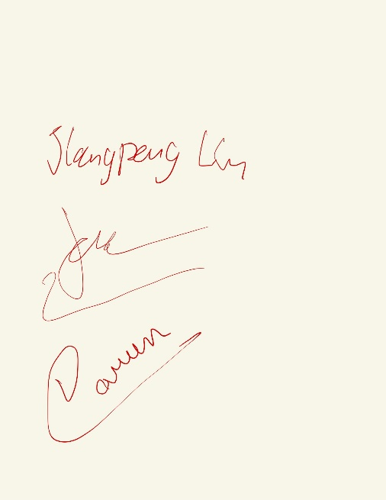

|  |  |  |
| --- | --- | --- |
| _________Jiangpeng Liu___________  Signature |  | __________01/06/2023_____________  Date |
| ________Minh Long Vu____________  Signature |  | __________01/06/2023_____________  Date |
| ________Varun Singh______________  Signature |  | __________01/06/2023_____________  Date |
| ________Divyanshu________________  Signature |  | ___________02/06/2023_____________  Date |

# **1. TABLE OF CONTENTS**

**1. TABLE OF CONTENTS** 3

**2. INTRODUCTION** 5

**3.** **CONTEXTUAL INQUIRY** 5

**3.1. Existing system** 6

**3.1.1 Existing apps** 6

**3.1.2 Advantage and disadvantage** 8

**3.1.3 Feature analysis** 8

**3.2. Survey** 9

**3.2.1 Design the survey questions** 9

**3.2.2 Analysis of survey data** 10

**3.3. Interview** 11

**3.4. Affinity Diagram** 14

**3.5. About our domain** 15

**4. CONCEPTUAL DESIGN** 15

**4.1. System concept** 15

**4.1.1 Problem statement** 15

**4.1.2 High level description of how the system work** 16

**4.1.3 Interaction Paradigm and Mode** 16

**4.1.4 Metaphor – system, interaction & interface** 17

**4.2 UX Requirements** 18

**4.2.1 User Scenario** 18

**4.2.2 Storyboard** 19

**4.2.3 UX Goals and Metrics** 20

**5. PROTOTYPE** 21

**5.1 Low-fidility prototype (Initial idea)** 21

**5.2 Low-fidelity prototype (version 2)** 22

**5.3 Mid fidelity prototype** 23

**5.4 Principle of UI design** 25

**5.5 Interaction flow** 26

**5.6 Interactive component** 26

**5.7 Testing** 27

**5.8 Changes after testing** 28

**5.9 UI Design** 30

**5.10 High-fidelity prototype** 30

**6. FUTURE DIRECTION** 32

**6.1 Possible additional features** 32

**6.2 Possible integration with external services or data** 32

**6.3 Future process** 32

**7. TEAMWORK** 33

**7.1 Weekly meeting logs** 33

**7.2 Individual reflection** 33

**8. REFERENCE (APA 7th)** 33

**9. APPENDIX** 34

**9.1 Individual reflection** 34

**9.1.1 Minh Long Vu** 34

**9.1.2 Jiangpeng Liu** 36

**9.1.3 Varun Singh** 37

**9.1.4 Divyanshu** 38

**9.2 Meeting Logs** 39

**9.3 Interviewing notes** 62

**9.3.1 Interview questions** 62

**9.3.2 Interview responses** 63

**9.4 Survey summary** 65

**9.4.1 Interview questions** 65

**9.4.2 Survey answers** 66

**9.5 Benchmark test description** 67

**2. INTRODUCTION**

We spend about two months on this project, from the beginning of April 2023 to the end of May 2023. Our team has four people: Long (writing, research and design), Varun Singh (research), Jiangpeng (research and design) and Divyanshu (research). The project is about a friend-finding application we design for the mobile platform. There are some tools we used: Miro, Adobe and Figma.

This is an overview of process we did to get the result:

**Research existing apps**

**System concepts**

**Conduct interview**

**Conduct online survey**

**Future**

**High-fidelity prototype**

**UX Requirements**

**Mid-fidelity prototype**

**Testing**

**Low-fidelity prototype**

**Figure 1: Project process**

**3.** **CONTEXTUAL INQUIRY**

Initially, we do a real-time location app that can help people to find a friend just by turning on their location to find some friends nearby. However, after researching the existing apps (Zenly, BFF,…), we figure out that these apps are fully functional, so we can’t find anything to improve from these. Therefore, we removed the function of real-time location and started doing the friend-finding app that can use the filter to find wanted friends.

## **3.1. Existing system**

There are several apps for friend finding. People need to go to Appstore or Google Play and search “Finding Friend”, and then hundreds of apps about this appear. We choose three apps that have the most downloads and ratings to start doing research.

### **3.1.1 Existing apps**

There are some existing apps like Hoops, Friender and Meetup, which helps people to find new friends nearby. We researched them to know how these apps work in the world today. Then, we compare the advantages and disadvantages of these existing apps.

* Hoop

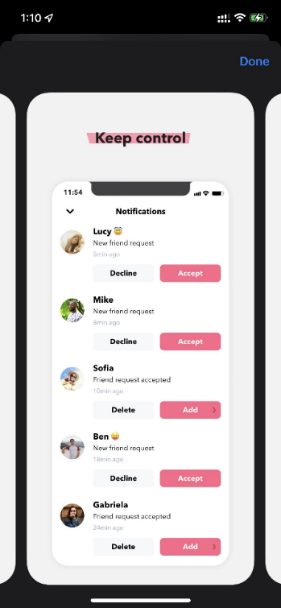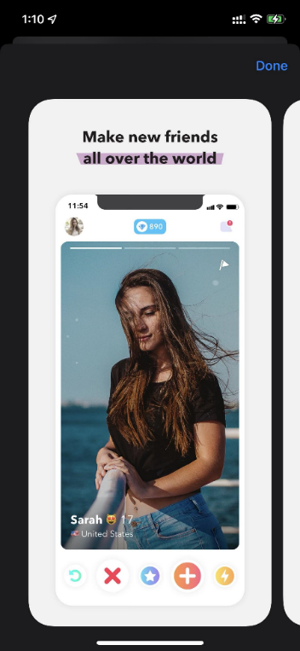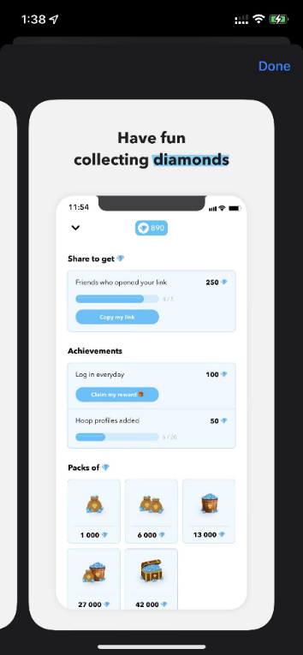

**Figure 2: Hoop app**

Firstly, Hoop is a popular app for teenagers. The app is a fun and easy way for young people to make new friends and socialize online. Hoop has a user-friendly UI, and it allows users to filter to search for friends by age, gender, and location. Especially one unique feature of Hoop is that it allows users to send virtual gifts to their friends and colourize their friend requests, which can help them quickly to start a conversation.

* **Friender**

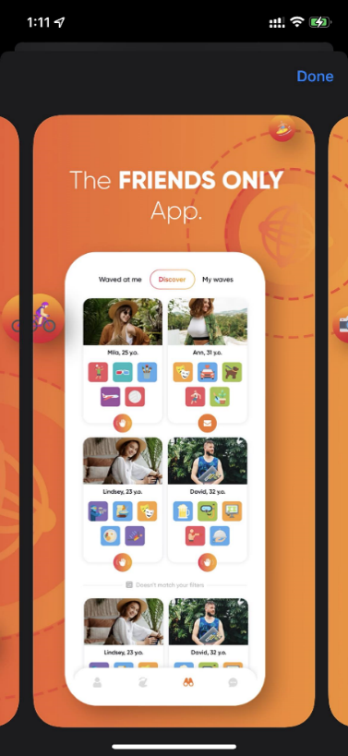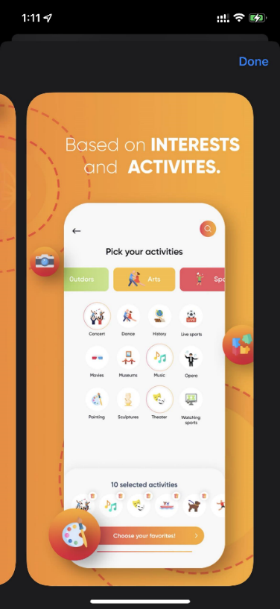

**Figure 3: Friender app**

Secondly, Friender is another app designed to help people make new friends. Unlike Hoop, Friender is not limited to teenagers. Anyone looking to expand their social circle can use the app. The app allows users to create profiles and search for other users based on interests and hobbies. Friender uses a unique algorithm to suggest potential friends, and users can use the swipe function to search profiles and send messages to people they are interested in.

* **Meetup**

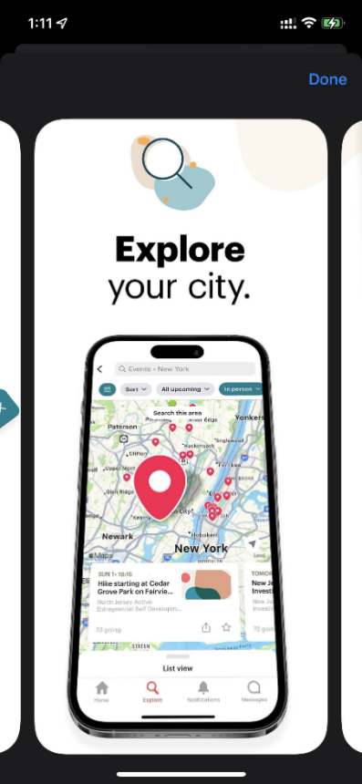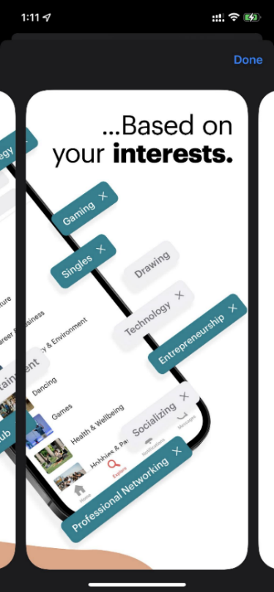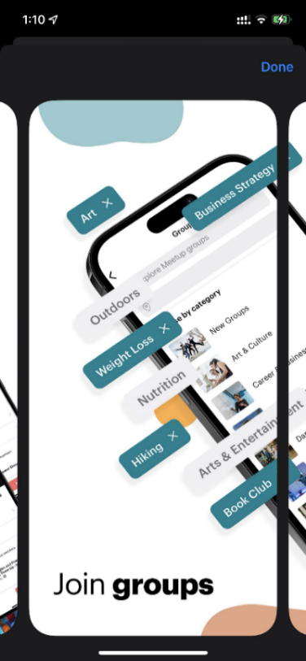

**Figure 4: Meetup app**

Thirdly, Meetup is a popular app designed to help people find and join groups of individuals who share their interests and hobbies. Users can search events and groups based on locations, interests, types of events and time. Then, they can attend these events and wait for acceptance from the founder. Besides, users can also know how many people will join and some information about them so that participants can find they are suitable or not. Therefore, Meetup is ideal for people looking to find new friends, events and groups in a new place with which they are unfamiliar.

**3.1.2 Advantage and disadvantage**

After using the apps for few days, we conduct some analysis for 3 apps above:



**Hoop**

**Friender**

**Meetup**

* **Advantage**:

- Able to set event goal and show with others.

- Message allowance settings.

* **Disadvantage**:

- Can’t add friends with others.

- Too many advertisements.

* **Advantage**:

- User-friendly UI

- High ratings and downloads

* **Disadvantage**:

- Must pay to use the main feature.

- Less option for filter.

* **Advantage**:

- Must use real image for avatar.

- Include various options for filter.

* **Disadvantage**:

- The app doesn’t request users to use photo, information, …

**Figure 5: Advantage and disadvantage of existing apps**

Hoop, Friender, and Meetup are all great apps for people looking to make new friends. Hoop is designed for teenagers and has a fun and user-friendly UI, while Friender is more focused on matching users based on their interests and hobbies. Meetup is unique because it allows users to join groups and participate in real-life activities and events.

However, in terms of Hoop and Friender, I believe they do not play their role rightly because they are more like dating apps but not finding friends to chat with or share. The reason is that the algorithm they use to attract more people who want to appear more opposite gender makes it become a dating app. Therefore, we decided to work on our app to help others feel better in new locations.

### **3.1.3 Feature analysis**

Then, I compare some of the features between apps to have an overview of the needs and values of these apps.

|  |  |  |  |
| --- | --- | --- | --- |
| **Feature Name** | **Hoop** | **Friender** | **Meetup** |
| **Main features** | | | |
| Various language | Yes | No | No |
| Paid version | Yes | Yes | Yes |
| Personal chat | Yes | Yes | Yes |
| Group chat | No | No | Yes |
| Share location | No | No | Yes |
| Send image | Yes | No | No |
| Profile | Yes | Yes | Yes |
| Friend list | Yes | Yes | No |
| Hobbies filter | No | Yes | Yes |
| Show interests | No | Yes | Yes |
| User description | No | Yes | No |
| **Privacy** | | | |
| Verify profile | No | No | No |
| Privacy settings | No | No | Yes |
| Request user’s authority | No | Yes | Yes |
| Delete account | Yes | Yes | Yes |
| **Other features** | | | |
| Sound | No | No | No |
| Notification | Yes | No | Yes |
| Swipe to choose | Yes | Yes | No |
| Contact us | Yes | Yes | Yes |

**Figure 6: Feature Analysis Table**

Although Friender has a user-friendly UI and a more extensive community, the filter needs more options. Especially, finding friends on Friender is much easier with block view instead of swipe to search, which only allows one to search for one person per swipe. Hoop requires lots of money to get more features. Otherwise, the people searched will be repeated. Finally, Meetup is designed to help people to find clubs rather than to make friends. Even though Meetup doesn’t have a friend system, people can still send messages to each other.

**3.2. Survey**

**3.2.1 Design the survey questions**

We started by looking at the types of questions to get as much data as possible. Besides multiple-choice questions, we found that a 5-point scale (Likert) question is suitable for getting more data. We divided the survey question into three parts. The first part is about characteristic questions. We ask people about their personalities, situation, and thoughts about friends. The second part concerns how people use mobile apps nowadays, like which features they prefer, feel good or feel safe. The final question is optional. If they have used any apps about our domain, they can answer some of the questions in this part.

**3.2.2 Analysis of survey data**

We used Google Forms to collect responses from 96 individuals. We found a high percentage of participants (33.3%) were introverts. The results showed it could be difficult for introverted people to find new friends.

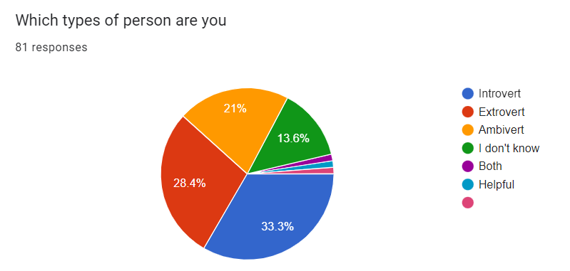

**Figure 6: Types of person**

We also found that most people (36%) made friends through social activities, like clubs and events, so we tended to add an event-finding feature in the prototype.

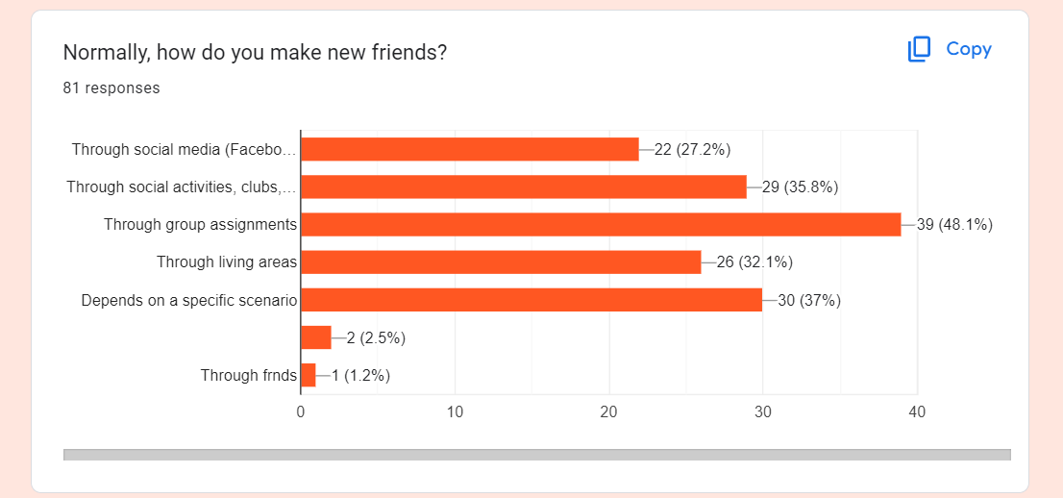

**Figure 7: How people make friends**

And 55% of people think that they can quickly become friends if they are in the same clubs or have the same hobbies and characteristics. Therefore, it would be an essential feature to include in our prototype.

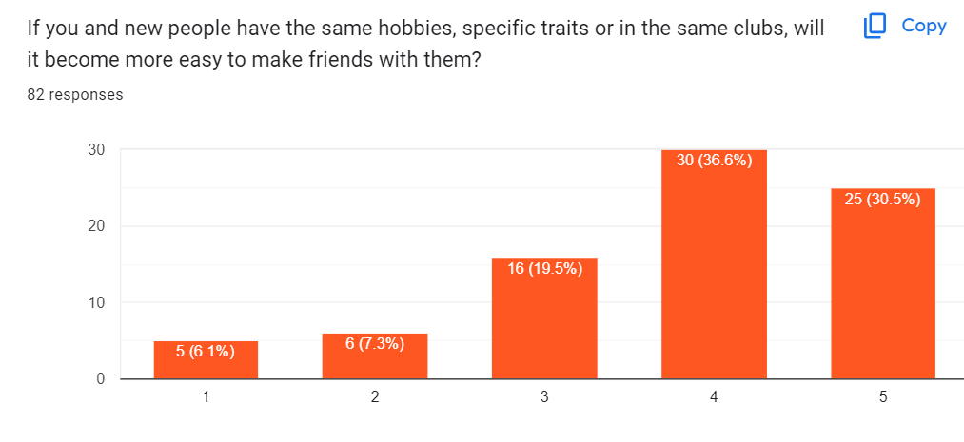

**Figure 8: How people choose their friends**

Most people believe that it is necessary to make friends when they go to a new place. Therefore, in our prototype, we will design a feature to show users nearby.

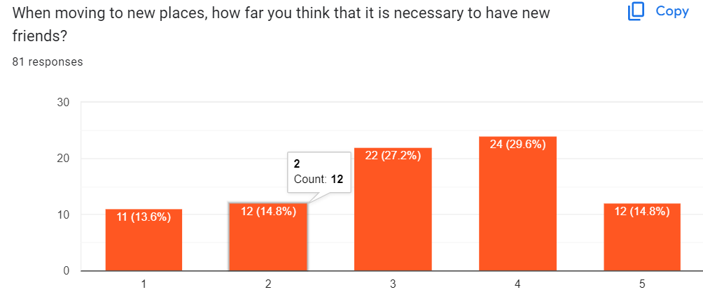

**Figure 9: How necessary to make friends in new place**

**3.3. Interview**

Our team conducted interviews with 12 people, and their responses were summarized, based on which an affinity diagram was made. The interview questions summarized questions about the existing app, the problems faced by the users and suggestions about the new app. The question and detailed notes of interview we put in appendix.

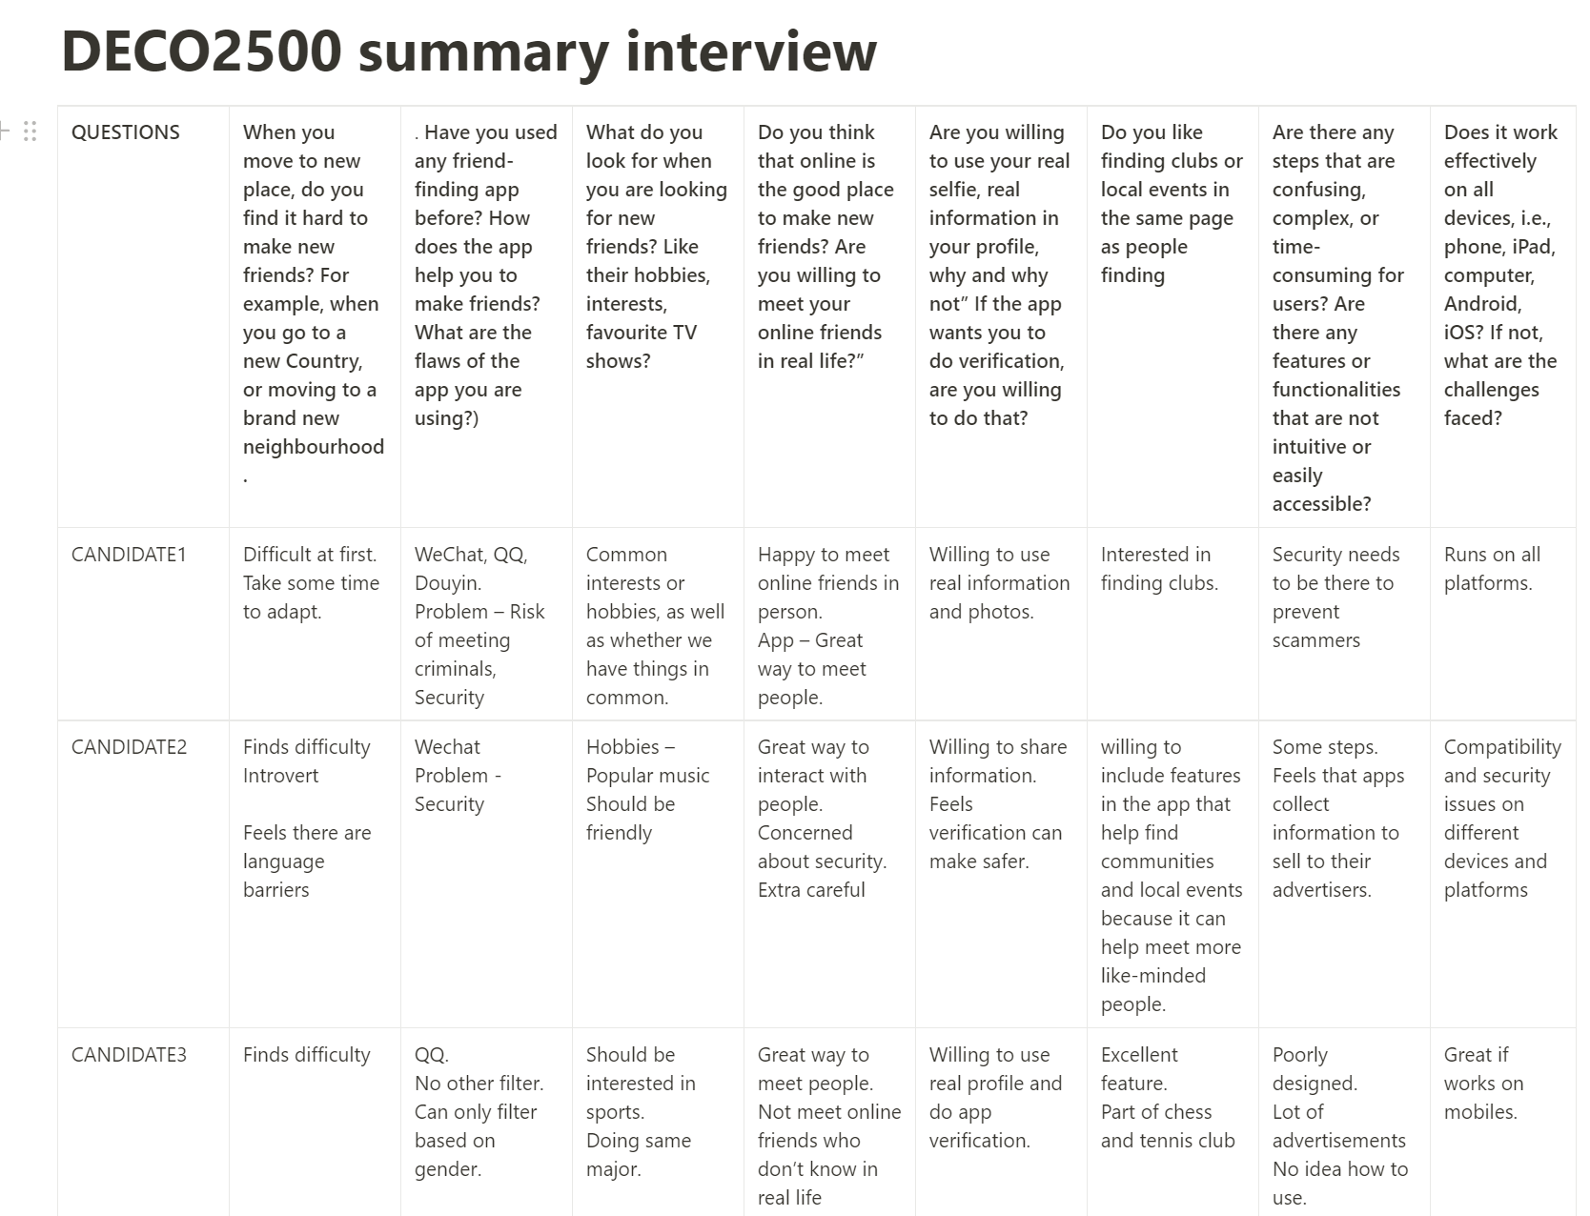

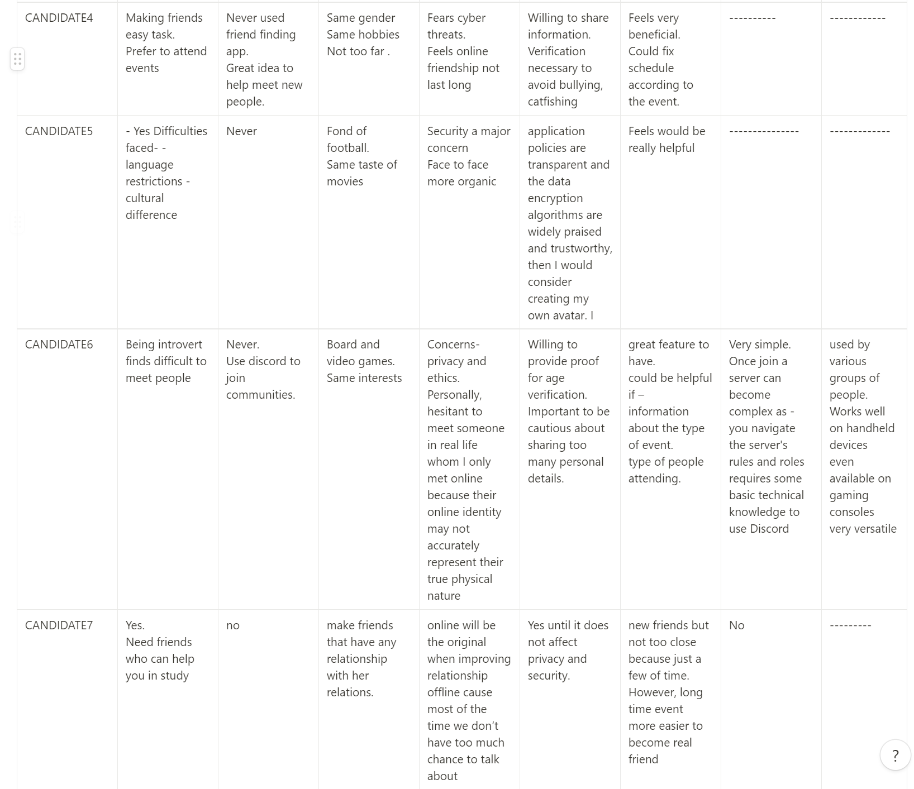





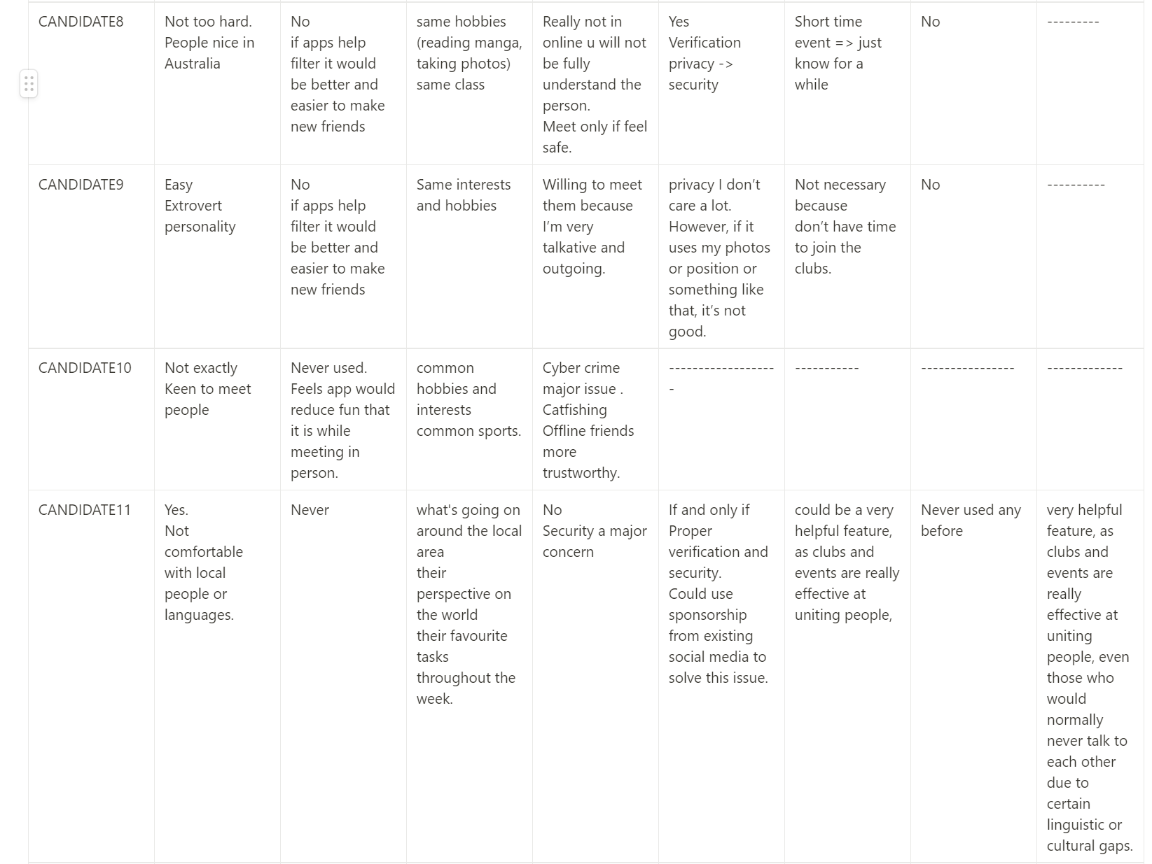

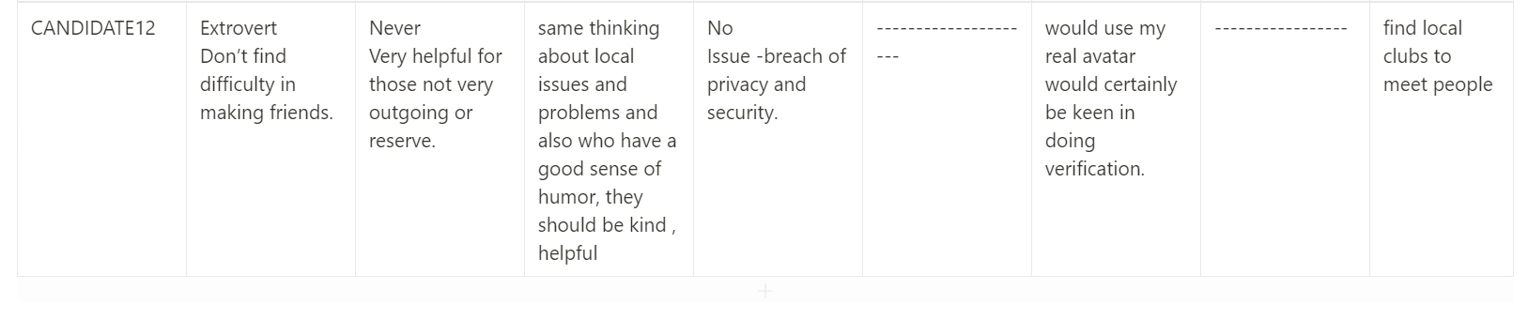

**Figure 10: Interview summary**

**3.4. Affinity Diagram**

I first wrote everything on sticky notes using Miro based on the data we collected. Each of the notes will have one piece of information. We call it raw data:

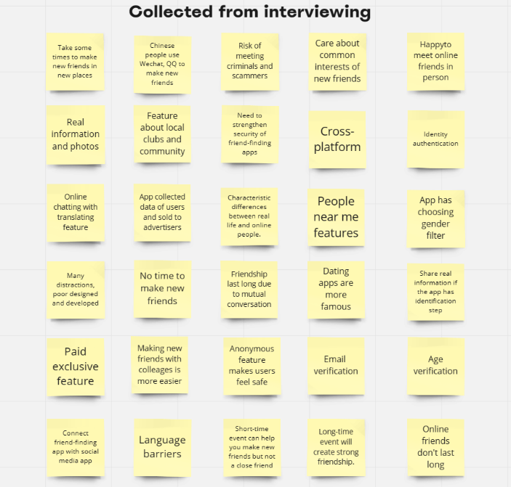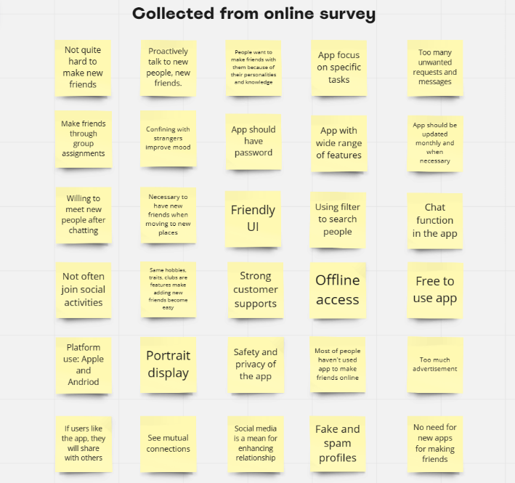

**Figure 11: Data collected from online survey and interviewing**

After that, we rearranged and grouped the notes with relevant information. Finally, we labelled them based on mutual information.

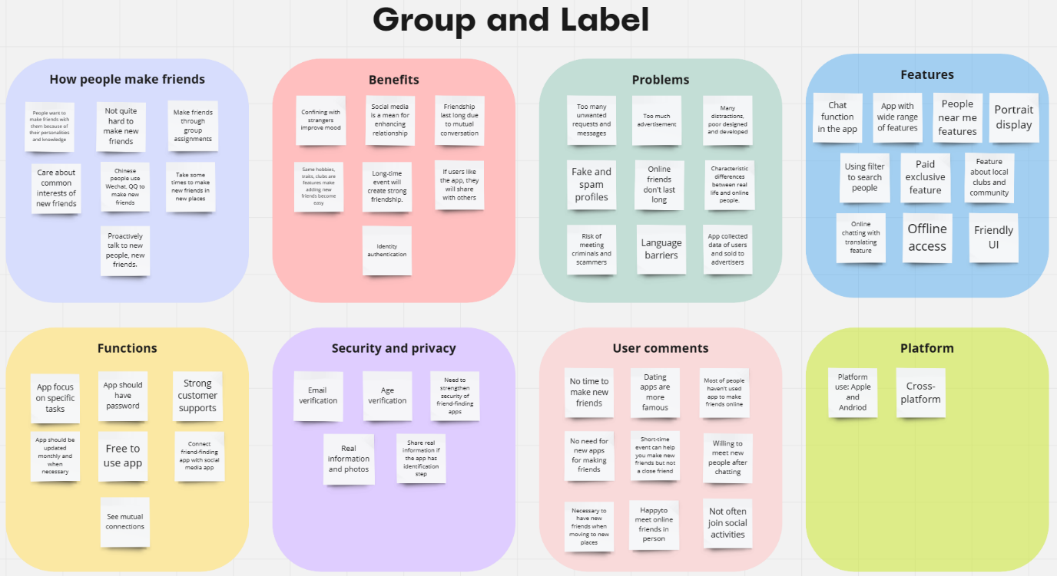

**Figure 12: Affinity diagram**

## **3.5. About our domain**

We selected the Discovery domain. We found that it was difficult for introvert people to make new friends. We aim to create a technology that helps young adults make new friends. Technology can help connect different people and communities in an increasingly connected world. Therefore, we will create an initial app concept that allows people to discover new friends, clubs, and activities. We will integrate our app with other external services to reach a broader user base. We will also undertake more user testing to improve usability and user experience.

About the challenge, since we were creating an app for a broader user base, the users might use it for various reasons like dating, scamming, and casual friend-making. We must consider security to prevent people with malicious intent from abusing the app. One of the possible solutions we proposed during the brainstorming process was profile verification. Another challenge was the personalization of the app. People had different tastes, and user preferences would be hard to measure.

The broad user base we were targeting contributed significantly to the above challenges. The surveys and interview data also raised some challenges. We had thought carefully about how to tackle these challenges before we started making a prototype.

**4. CONCEPTUAL DESIGN**

**4.1. System concept**

The world has become more and more connected by the internet. People chat with each other while they are thousands of kilometres away. However, one problem emerges: some people have trouble making real friends. We already found in an earlier section that the existing systems did not provide sufficient help to users. In this section, we strived to identify the current problem. We will briefly describe how our system works to solve the problem.

**4.1.1 Problem statement**

Given the existing problem, introverted people would have difficulty finding friends in real life. The survey found that people were more willing to talk with others on the online platform. After knowing each other for a while, they would like to meet and become genuine friends. The system should support all mobile platforms because almost everyone has their phone in their pocket all the time. Most people care more about their potential friends' interests and want to find like-minded people. Therefore, the system must support filtering users based on their personalities and interests. Mobile applications provide quick notification, and a chat application's speed of response is critical.

The one-sentence problem statement is:

"Develop an application on mobile platforms that help introverted people to foster friendships by utilizing suggestion algorithms based on interests and hobbies."

**4.1.2 High level description of how the system work**

The system addresses the problem that users find it difficult to make friends or engage in activities that resonate well with their interests. The system is designed to meet the needs of people who cannot make friends outside their work/study environment or are introverted and cannot interact with people due to language barriers or cultural differences. The system provides essential functions that meet the users' requirements. The user can filter people based on age, interests and hobbies and make friends with them. The users can enter their interests and hobbies, which helps the system suggest people who can be friends with the users. One of the system's essential features is that people can find events of interest throughout their city. The system keeps the users updated about the various events happening in the city, which helps the users in fostering friendships. The system aims to get positive user feedback, thus removing isolation and loneliness from the life of users and providing them companionship. The system emphasises ease of use, efficiency and user satisfaction so that users can get a smooth interaction experience.

**4.1.3 Interaction Paradigm and Mode**

There are many Interaction paradigms, but the paradigm that would work appropriately for our system is Mobile/Wearable Devices.

In line with the system's requirements comes the need for a user-friendly and efficient paradigm that would optimally serve its purpose while being easily accessible to all users at any time and place. A mobile application is a viable solution given its potential benefits, such as portability that makes it convenient for users wherever they may be. A mobile application is the most appropriate because it has excellent portability and accessibility. Certainly, users can interact with other users and find events according to their interests through the convenience of their mobile phones. The mobile paradigm utilizes gestures such as swiping, dragging, and pinching to navigate, interact, and manipulate content within the system. Touch-based interaction is the best because it makes the interaction with the system more effortless and less time-consuming. Voice commands are another feature of the mobile paradigm that makes it more suitable for this prototype because users can use voice commands to search, filter or initiate a conversation with friends. It also certainly reduces the need for physical interaction.

The mobile paradigm leverages the capabilities of mobile devices, such as location tracking and sensors, to provide context-aware features.

**4.1.4 Metaphor – system, interaction & interface**

The final part of the system concept is metaphor. System, interactive and interface metaphors help simplify complex ideas by mapping them onto more familiar and known domains, making them easier to understand and work with, and they also provide users with a conceptual framework to interpret and interact with abstract concepts in a way that aligns with their existing knowledge and experiences.

**System metaphors** allow designers and developers to understand the system's components, relationships, and interactions, guiding their decision-making process, and this also helps stakeholders and different non-technical people to understand how the prototype will be structured and how different things work together.

**Interactive metaphor** allows designers to understand how users interact with the system. Conceptualising the interaction, or physical conversation, helps designers make more user-intuitive and user-friendly interfaces, thus helping us shape our prototype to be more valuable for the intended user base.

**Interface metaphor** allows the development of prototypes familiar to the user and their everyday life. It makes it easier for the user to navigate freely through the user interface. The designers can use prior knowledge about the interface with which the user interacts the most to develop an even better interface.

**System Metaphor: "Event Discovery Engine"** is a personalized assistant providing recommendations and information about social events tailored to users' interests and preferences. It is a proactive and intuitive platform to help students navigate the social event landscape effectively. This system metaphor emphasises the role of discovering nearby social events.

**Interface Metaphor: "Social Space**" is a guide and navigation tool for social events. It helps her explore different event categories, filter and refine search results, and presents relevant event options on a digital map or list format. She can view the event attendees, add them to a friend list, and the social space has a chat feature to ease communication. The interface metaphor emphasises the role of the tool in guiding the user towards social opportunities.

**Interaction Metaphor: "Social Navigator"** assists the student throughout her event discovery journey. This metaphor represents an interactive and supportive companion that provides personalized suggestions, offers event details and recommendations, and assists in planning and organizing attendance, helping attendees discover their friends from the friend list through an interactive live location feature. The interaction metaphor highlights the system's role in guiding and supporting the user's social exploration.

## **4.2 UX Requirements**

We created a storyboard, user scenario, and interaction scenario to set the foundations for our prototype. The user scenario specified what our potential users wanted to see in our app and how it would help to solve an existing problem. The storyboard created a graphic representation of the user scenario, which helped our UX designer to understand the context better. The interaction scenario demonstrated proposed the interaction of the app.

### **4.2.1 User Scenario**

Consider one scenario based on our interviews.

“Jane Doe, A female Master’s student who finds making friends outside the workspace quite hard. She would love to attend some social events but find it quite hard to find these events. She had some expectations for the app. First, she would love the app to have some verification process. Therefore, she can know that she is talking to an authentic person. One day, she tries to find an app on the Appstore that fits for needs, finding friends or social events quickly. She downloaded Facebook, one of the most popular social media apps. She used the “Events near me” feature but found events requiring a mandatory entry fee.

Most events on Facebook are commercial, like concerts, Yoga, and Workshops. She tries to filter the events based on categories. Unfortunately, Facebook redirected her to an error page with a text saying, “This page isn’t available at the moment”. Out of anger, she uninstalled Facebook and tried a different app. She constantly sought an app to filter people based on interests and hobbies. Jane expects the app could have some form of verification process because she had safety concerns on a digital platform. She would gain more confidence chatting with strangers if the stranger was verified and confirmed to be authentic. Jane liked to play tennis, so she wanted to join a tennis club. Therefore, the app should be able to filter clubs based on sports or activities.”

### **4.2.2 Storyboard**

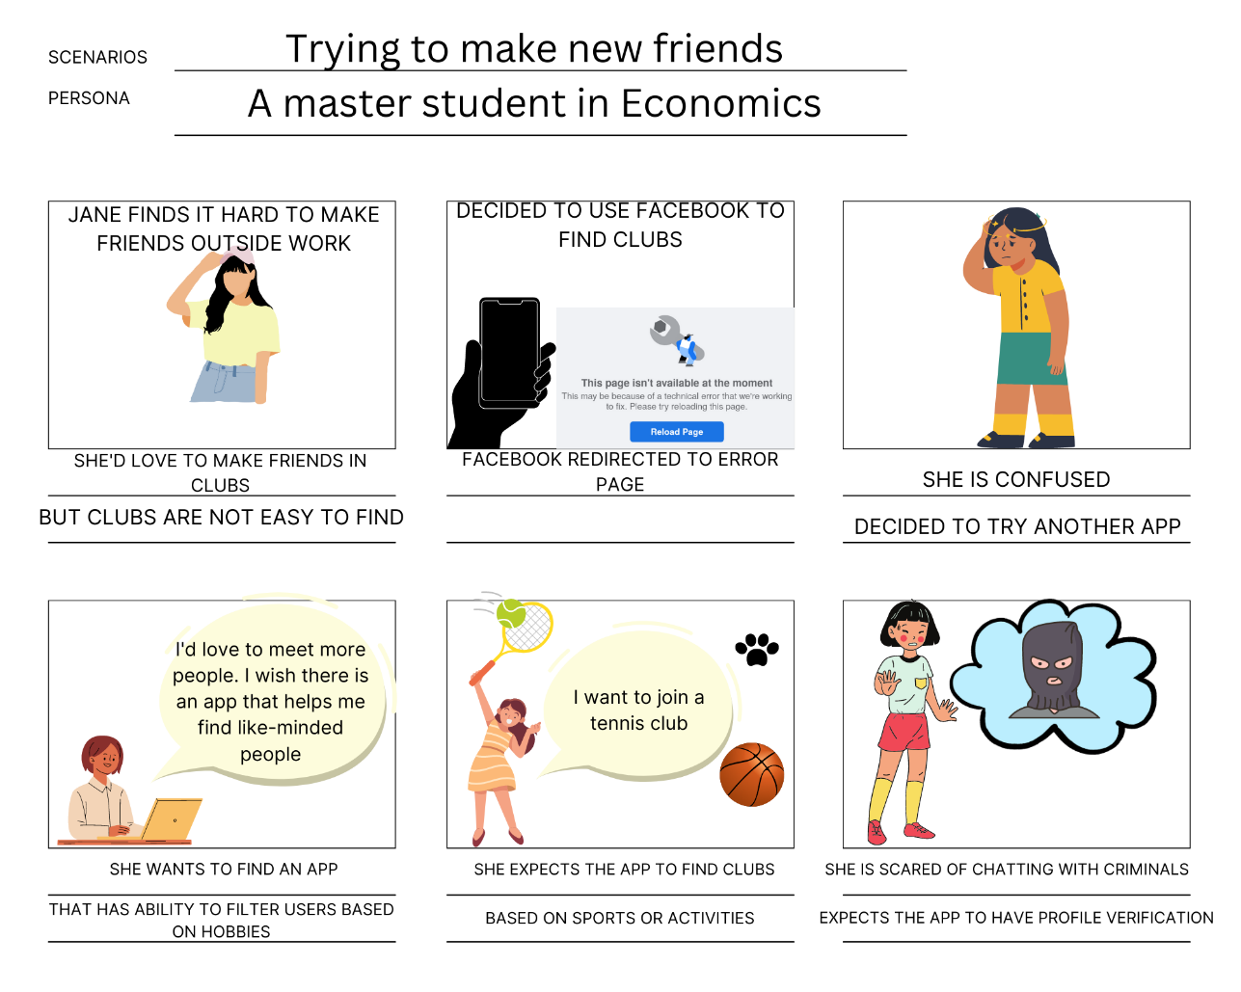

Jane got a new job and she’d love to have friends outside work.

She tries to start to find some clubs on Facebook, where she can easily make new friends. However, clubs on Facebook are rare and not working.

She’s stressed about her job, but it’s hard for her to have friend because she can’t proactively talk with others.

She wishes that there will be an app for introvert person like her.

The app will help people connect based on hobbies and activities.

She used to have bad experience with scammer in other friend-making apps.

**SENARIO:** Trying to make new friends.

**PERSONA:** A Master of Economics student finds. hard to make new friends because she is introvert.

**S**

**Figure 13: Storyboard**

Jane was a master’s student studying Economics who found it difficult to make friends outside work. She wanted to make friends in clubs, but finding new clubs was challenging. She went to Facebook to find clubs. Unfortunately, Facebook has few numbers of clubs and usually redirects her to an error page saying the feature is unavailable. Jane was tired of her job, and she wanted to have friends to enjoy her free time after work. She’d love to find an app to help her find like-minded people. She would also like to join a tennis club. Therefore, the app should be able to filter clubs based on activities. She feared scammers and malicious people on the online platform, so she expected the app to have safety mechanisms like profile verification.

**4.2.3 Interaction Scenario**

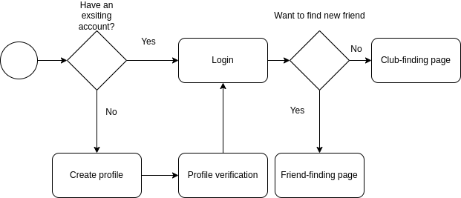

**Figure 14: Interaction Scenario**

The user interaction scenario provided a foundation for the prototype stage of this report. We designed it to help the UX designer better understand the process of the app. The format of the user interaction scenario followed the style of the programming chart. It captured key features from user data, like the focus on security.

### **4.2.3 UX Goals and Metrics**

There are several features we want to add to our apps. Firstly, profile pages, where people can change the settings, edit their name, profile description, theme and other things about privacy, help system. Before users can use that, we want them to create their profile, so benchmark test 1 (BT1) is about “Finish creating profile”. The UX Goal and UX Measure are about ease of use for new users and initial user performance, respectively. The reason is that this is the first step users need to do before using the app. About UX Metric, we decided to use Time on Task and Error Count because the quantitative data generated, which is “quick and dirty”, can help us to know how difficult it is to create the profile. With the baseline level, we have experienced some of the existing apps, so we can decide the baseline level by recording the time we do the benchmark test on these apps. With the target level, we estimate how we want our apps going to be; it cannot be perfect like the existing apps, so some of the target level we shorten the target. About other goals, we created the table below with eight benchmark tests and two types of users:

|  |  |  |  |  |  |  |  |
| --- | --- | --- | --- | --- | --- | --- | --- |
| **Work Role: User Class** | **UX Goal** | **UX Measure** | **Measuring Instrument** | **UX Metric** | **Baseline Level** | **Target Level** | **Observed Results** |
| Students who are familiar with technology | Ease of use for new user | Initial user performance | BT1: Finish creating profile | Average time on task | 5 minutes | < 5 minutes |  |
| Ease of use for new user | Initial user performance | BT2: Attend a music event | Average time on task | < 1 minute | < 1 minute |  |
| Ease of use for new user | Initial user performance | BT3: Log out account | Average time on task | < 1 minute | < 1 minute |  |
| Accuracy | Experienced  usage error  rate | BT4: Block a friend from the friend list | Average number of errors | < 1 | < 2 |  |
| Imitate from the previous step | Learnability | BT5: Finding a friend who from 22-25 and like cats | Average time on task | < 2 minutes | < 2 minutes |  |
| Experience the safety of the system | First Impression | BT6: Inbox to a verified user | Average number of errors | < 1 | < 1 |  |
| Users with little experience | Ease of use for user with little experience | Post initial performance | BT7: Message to a friend | Average time on task | < 1 minutes | < 2 minutes |  |
| Ease of use for user with little experience | Post initial performance | BT8: Unattended your event | Average time on task | < 1 minutes | < 2 minutes |  |

**Figure 15: UX Goals and Metrics before testing**

About observed results, we will record them after creating a mid-fidelity prototype. By doing that, it will help us test usability.

**5. PROTOTYPE**

**5.1 Low-fidility prototype (Initial idea)**

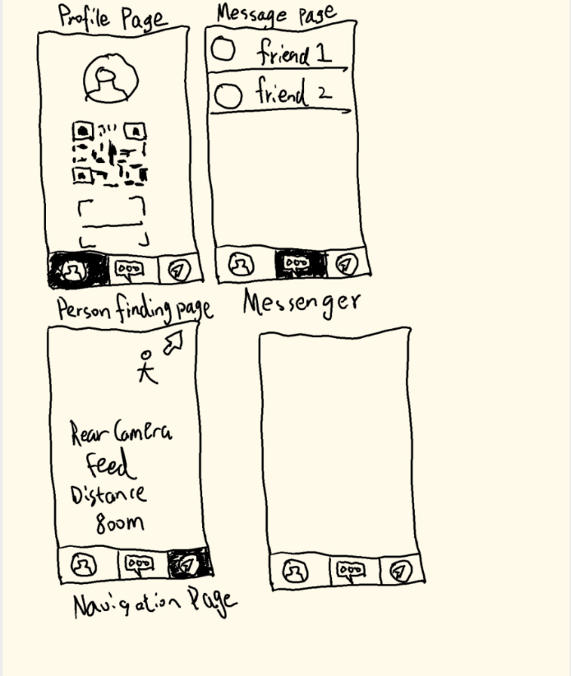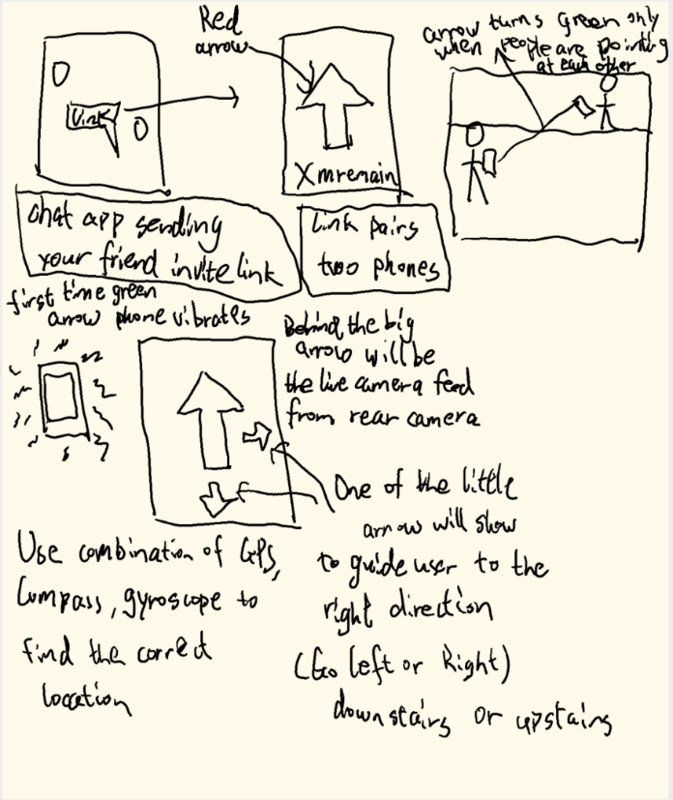

**Figure 16: Initial ideas about the app**

Initially, we wanted to create an application to help users to find their friend's easily in a large indoor setting. We changed our initial ideas after the first round of user surveys and interviews. In the initial prototype, two users hold their phones when pointing to each other in the right direction, and the arrow on their apps turns green. In the low-fidelity wireframe 1, users can share their location with their friends via a link. They can find each other with guidance from the arrows of the app. Once they are pointing in the correct direction, the phone vibrates. The wireframe follows a minimalist design concept. In Wireframe 2, the user can access different pages of the app. They can other users by scanning a QR code on the profile page. On the messenger page, users can chat with their friends. The app provides a convenient way for users to find each other on the navigation page.

## **5.2 Low-fidelity prototype (version 2)**

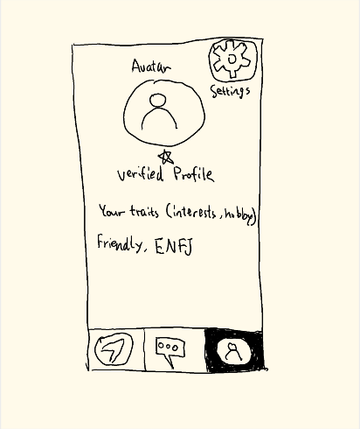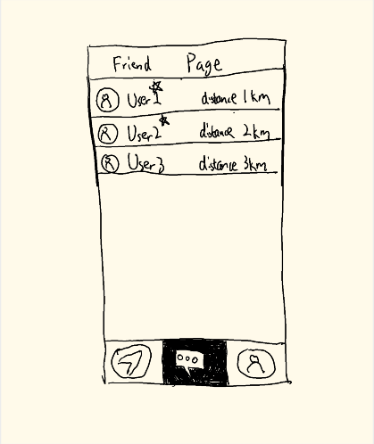

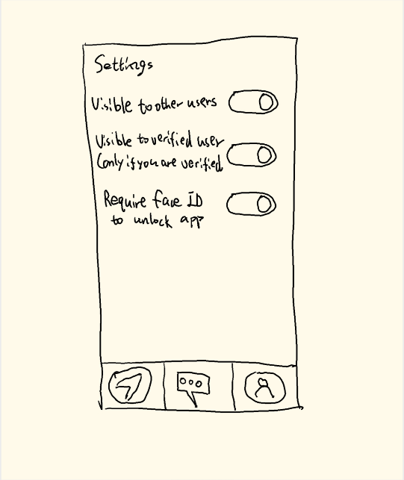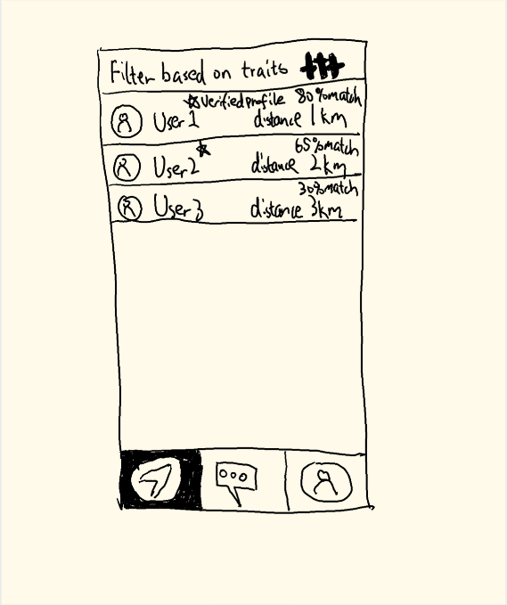

**Figure 17: Low-fidelity after having data**

After user surveys and interviews, we changed our prototype, which focuses more on finding new friends other than finding existing friends in an indoor setting. Users would have options like verifying their profiles, adding their traits to their profiles, and uploading a custom avatar. We also designed settings to protect user information because people expressed privacy concerns in the survey. Wireframe 1 shows an updated friend page where users can chat with friends. The profile page is on Wireframe 2, where users can verify their profiles or customize their traits. On the navigation page, we can see a list of friends with their approximate locations. On the settings page, the user can decide what information they want to share with others.

The design concept of the low-fidelity prototype adhered to the eight golden rules, striving to create a user-friendly design.

**5.3 Mid fidelity prototype**

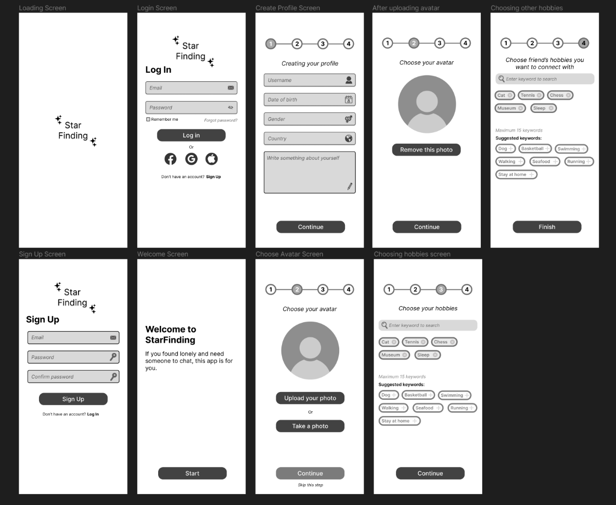

**Figure 18: Mid-fidelity first login process**

The first process includes nine pages above. The first page is a loading page, which people will see after opening the app. As we mentioned earlier, users need to create their profile before using the app, so users will go to building the page after logging in or signing up. We make six pages for this step. People will see our welcome message if this is their first use of the app. Then they must create a username, date of birth, age, and country and write something about themselves. Next, they must upload their avatar or skip this step. I created two pages for this; one is for uploading images, and one for removing images. The last two final steps are choosing their hobbies and other hobbies.

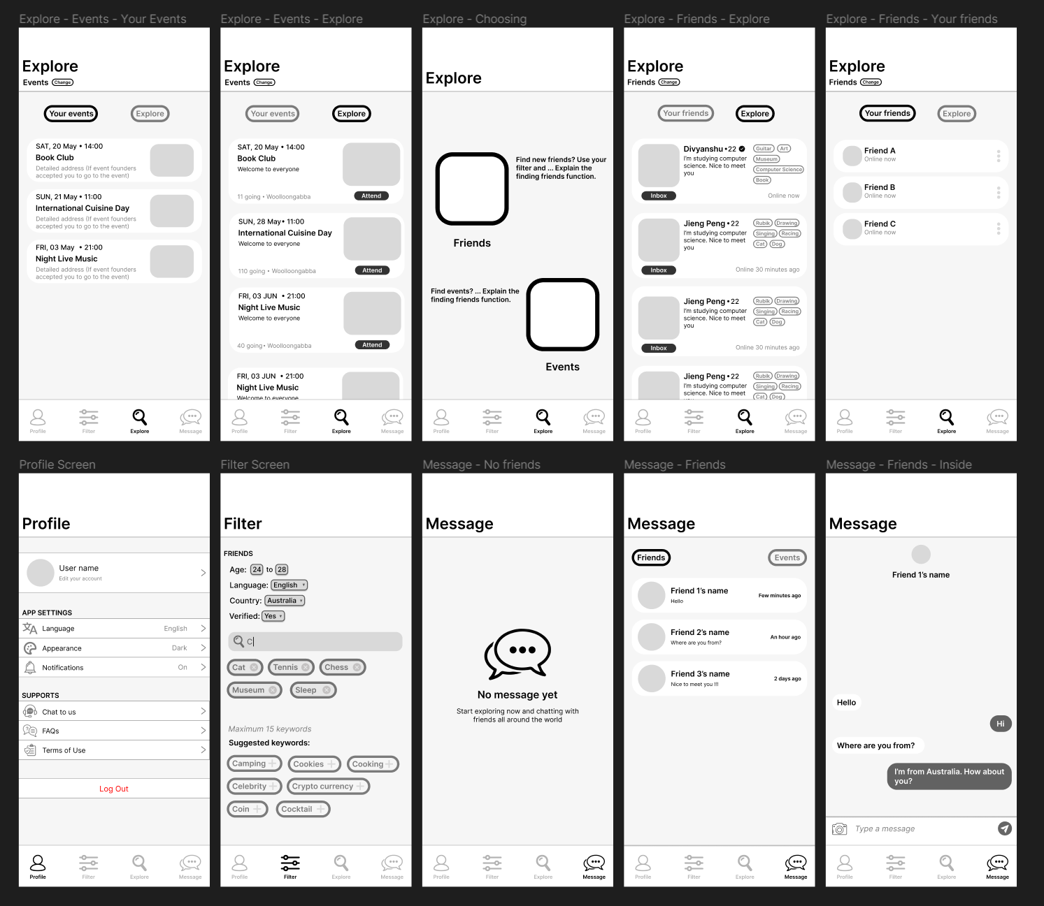

**Figure 19: Mid-fidelity main interaction**

The second process includes ten pages about primary interaction with the apps. It includes exploring, profile, filtering and message. In the explore pages, users have two options, one is finding friends, and one is finding events. If users choose the events, they will go to the left side, where they can see the event match with their hobbies in “Event Explore”. After they attend one event, the event will appear on the “Your Event” page. They will navigate to the right side if they choose to find friends. They will see their friends and their hobbies appear, and the status to know that they are online are offline. Users can click on inbox to start messages with them. If both of them feel good about being together, they can add friends and open more features like sharing location, calls, etc., but this part we will do this in the future. Besides the profiles, people can edit their profiles, themes, and notifications or get support from FAQ or Contact Us. In the Filter Page, They can choose the target users they want to make friends with; it includes age, country, hobbies, and verified users or not. Finally, in the Message pages, people can see recent friends who have chatted with them recently

**5.4 Principle of UI design**

Before doing the mid-fidelity, we researched text size, font and the phone's resolution. We decided to use the iPhone X, which has a 6.1" screen size of 896 x 414. Therefore, the reading text will be between 18 and 12 pixels, while the headers will have 24 pixels above.

We built the app based not only on system concepts and UX requirements but also on laws about reducing cognitive load. Two typical laws we followed were Miller's Law and Hick's Law.

**Hick’s Law**

**Miller’s Law**

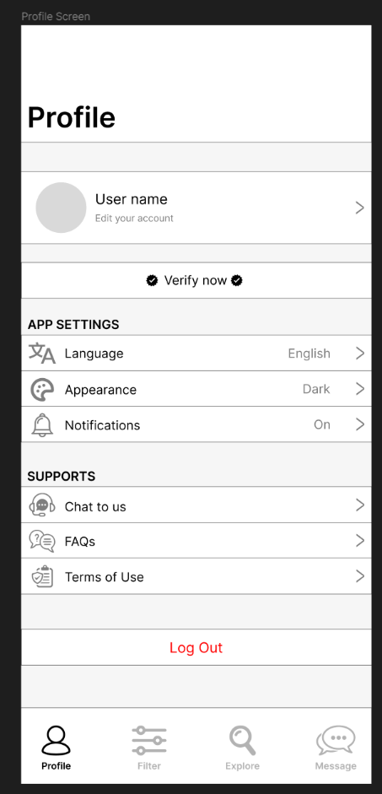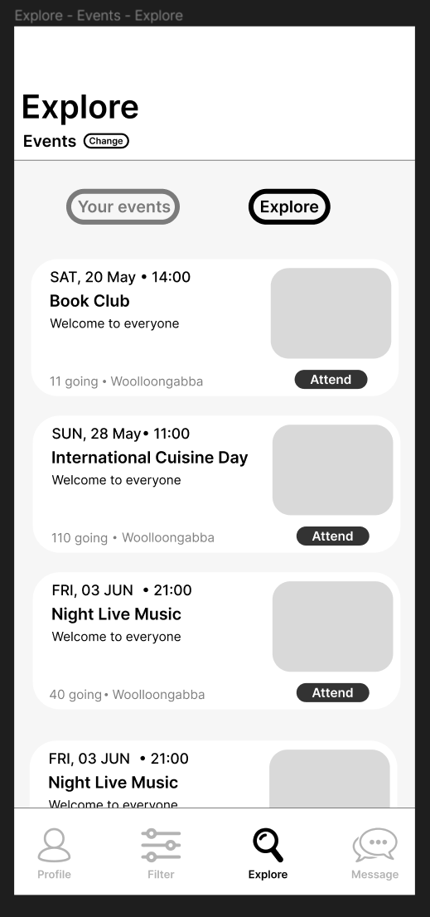

We separate profile, app settings and supports. Therefore, users can easily identify the function they need.

In Explore page, both friends and events will appear maximum 3 events or friends at the time. Therefore, the response time will be equal to 3.31 seconds

**Figure 20: Miller’s and Hick’s Laws application**

**5.5 Interaction flow**

After designing pages for the apps, we created an interaction flow diagram to visualise the app's navigation.

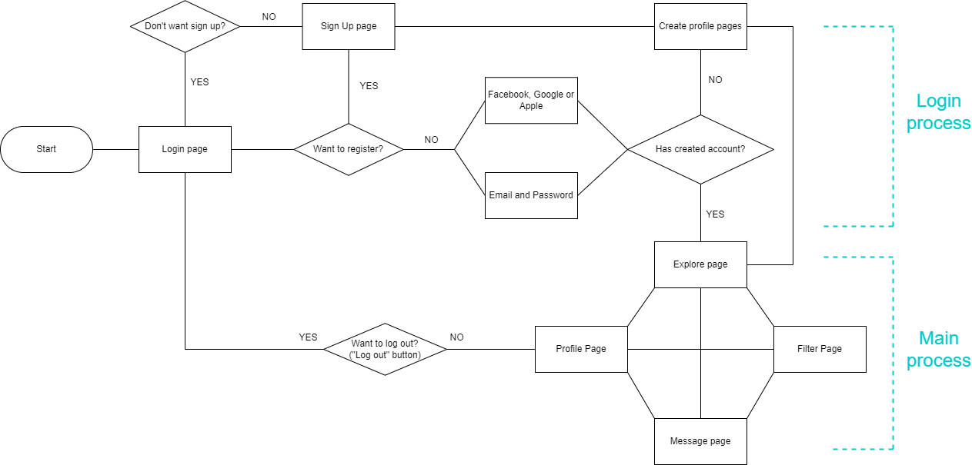

**Figure 21: Interaction flow diagram**

There are two main processes for the apps, and if the users have already created a profile, they will navigate to the primary process, which includes the main interaction with the apps. They can traverse through 4 main pages: Explore, Filter, Message and Profile. In contrast, if the users haven’t created an account, they can either sign up with their email or use their Google, Facebook or Apple count to create the profile. After finishing creating a profile, they will navigate to the main pages.

**5.6 Interactive component**

Then, we created variants for some button components to make the app more realistic and interactable. Besides, creating components will have us improve our efficiency while designing. For example, we don’t have to create two pages for two different states of a button, like selected and unselected.



**Unselected state**: If the button is not selected, this variant will appear.

**Hovering sate**: If users’ mouse is in the field of the button, this variant will appear.

**Selected sate**: If users make a left click to the button, this variant will appear.

**Figure 22: 3-state profile button**

About other components: check box, input field and options panel, we only created two states: Unselected and selected.

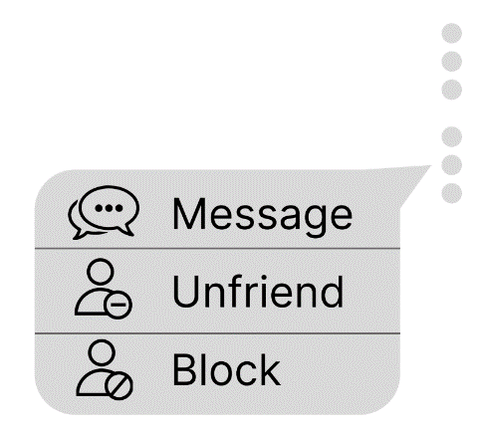

**Figure 24: Friend’s option variants**



**Figure 23: Check box variants**

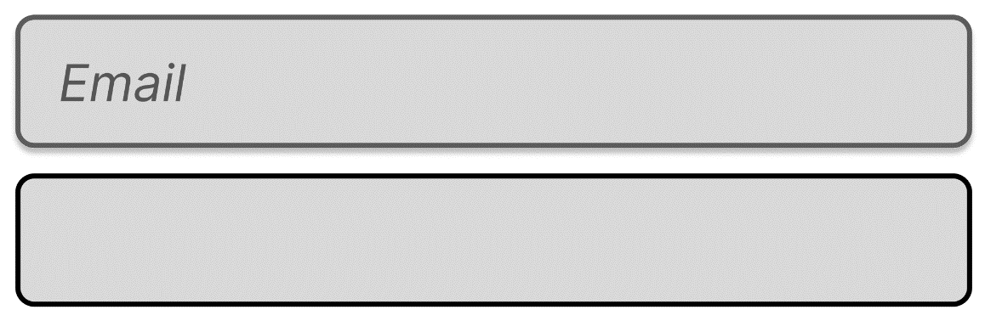

**Figure 25: Input field variants**

After finishing this step, we almost finished our mid-fidelity. Then, we need usability testing for our fidelity to feedback and to make some adjustments.

**5.7 Testing**

As mentioned above, we will test on three people for each test in this step. Then, we calculate the average number and get the result below

|  |  |  |  |  |  |  |  |
| --- | --- | --- | --- | --- | --- | --- | --- |
| **Work Role: User Class** | **UX Goal** | **UX Measure** | **Measuring Instrument** | **UX Metric** | **Baseline Level** | **Target Level** | **Observed Results** |
| Students who are familiar with technology | Ease of use for new user | Initial user performance | BT1: Finish creating profile | Average time on task | 5 minutes | < 5 minutes | 4 minutes |
| Ease of use for new user | Initial user performance | BT2: Attend an music event | Average time on task | < 1 minute | < 1 minute | 5 seconds |
| Ease of use for new user | Initial user performance | BT3: Log out account | Average time on task | < 1 minute | < 1 minute | 5 seconds |
| Accuracy | Experienced  usage error  rate | BT4: Block a friend from the friend list | Average number of errors | < 1 | < 2 | 3 errors |
| Imitate from the previous step | Learnability | BT5: Finding a friend who from 22-25 and like cats | Average time on task | < 2 minutes | < 2 minutes | 40 seconds |
| Experience the safety of the system | First Impression | BT6: Inbox to a verified user | Average number of errors | < 1 | < 1 | 4 errors |
| Users with little experience | Ease of use for user with little experience | Post initial performance | BT7: Message to a friend | Average time on task | < 1 minutes | < 2 minutes | 1 minute |
| Ease of use for user with little experience | Post initial performance | BT8: Unattended your event | Average time on task | < 1 minutes | < 2 minutes | 30 seconds |

**Figure 26: UX Goals and Metrics after testing**

We saw participants meet some problems during the BT4 and BT6. We found that people cannot find their friend list, and they also ignored the options button because the friend list is inside the explore page. Besides, on the message page, they can usually edit or find some settings about that, but we haven’t designed it yet. Another problem is that users ignore the verified icon, so they struggle with which one is a verified profile, even if there are only 2. With other benchmark tests, we believe our apps have user-friendly UI as users can quickly finish the test on time.

**5.8 Changes after testing**

Based on the testing results, there are some significant changes to the app's arrangement. For minor changes, we fix a few amounts of text size, margins of headings and contents and spelling errors.

Before

After

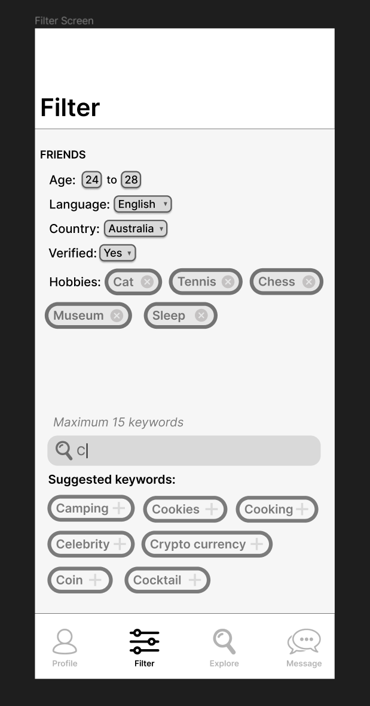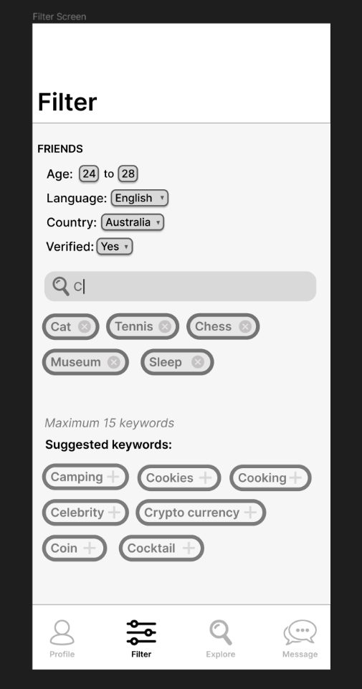

**What are these keywords for?**

For the types of hobbies that you want your new friends to have

**Before**: Lack of information about this part.

**After**: Add “Hobbies” for users know that what is this.

**How to use the search bar?**

The text you type will appear at the “Suggested keywords”

**Before**: That “Suggested keywords” part is too far from the search bar.

**After**: Move the search bar close to the keywords part.

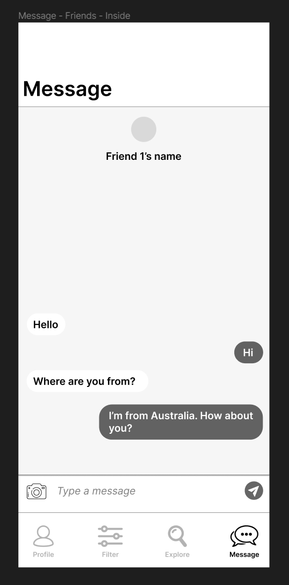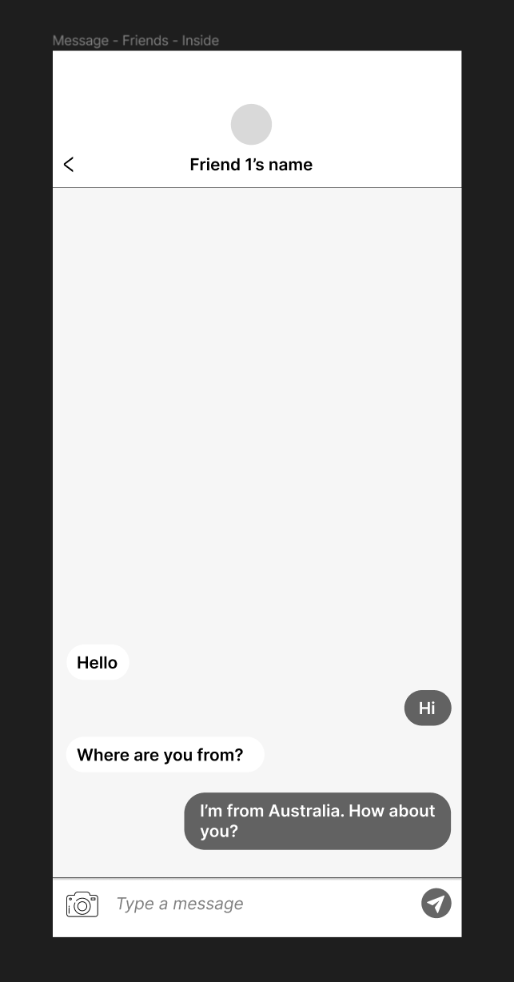

**How to go back to the friend page?**

**Before**: No way to go back. I found that user struggled about this when doing BT4.

**After**: Add back button on the top.

**BT8: Text something to your friend**

**Before**: Users might click wrongly to the menu parts when they want to enter text.

**After**: Remove that part and add back button for users to go back.

**Figure 27: Changes after testing**

## **5.9 UI Design**

We decided to use red combined with a gradient of orange and yellow to colourize our app. These colours can help users feel betters and more energetic, making them relax when finding new friends after a hard-working day. Other neutral colours are used for icons, options and disabled buttons.

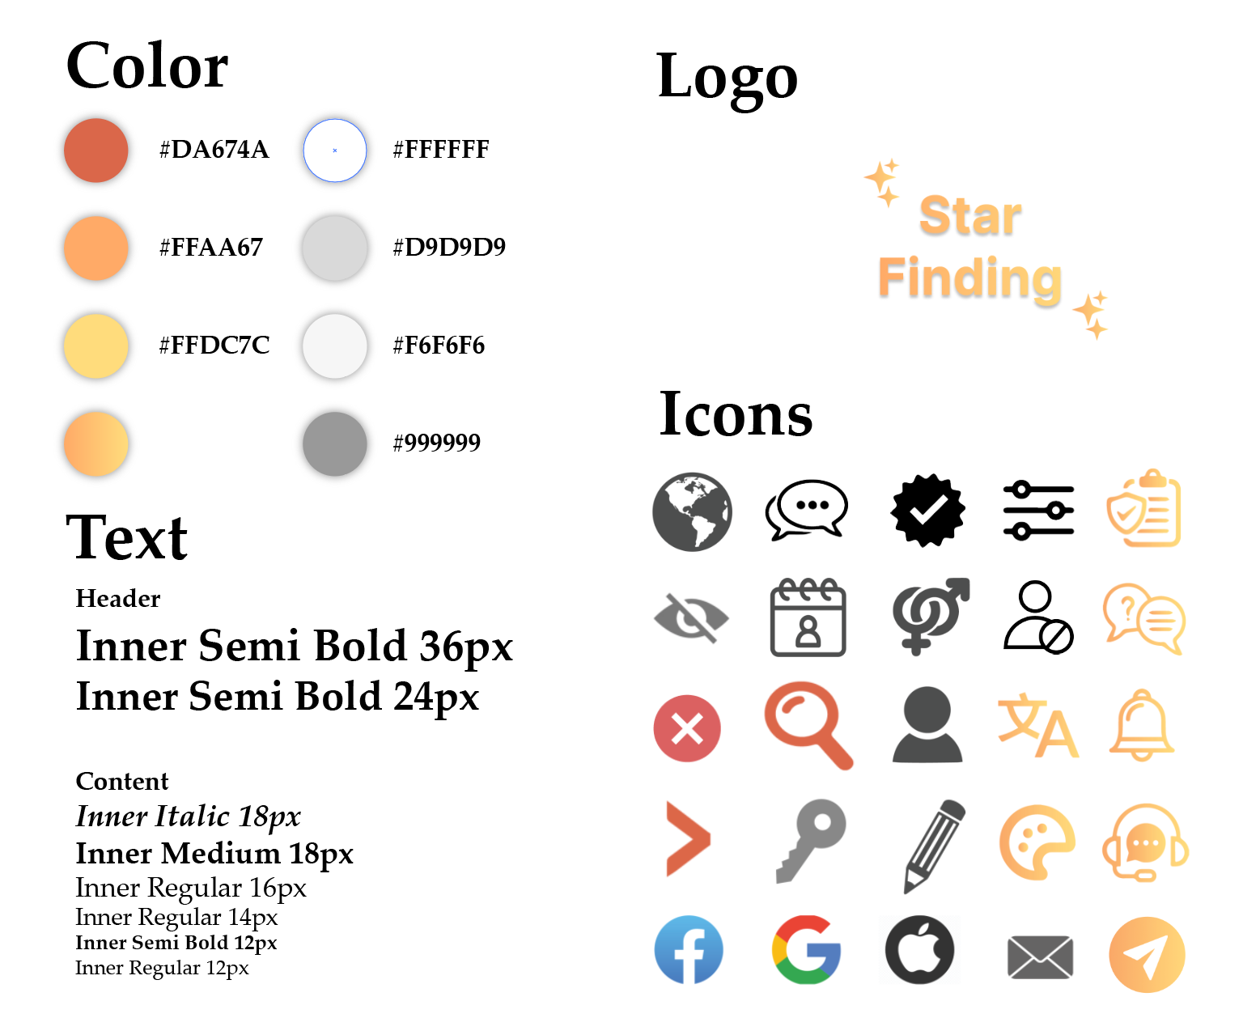

**Figure 28: UI Design**

**5.10 High-fidelity prototype**

Based on the interview, we noticed that users want to have the ability to customise their profile, like background colour, music, and font. By that, they can show some of their characteristics and hobbies. Others may be impressed and attracted by the way they design their profile or the same colour combinations with their profile. Therefore, I gave examples of users’ ability to customise their pages in the Explore events and explore friends.

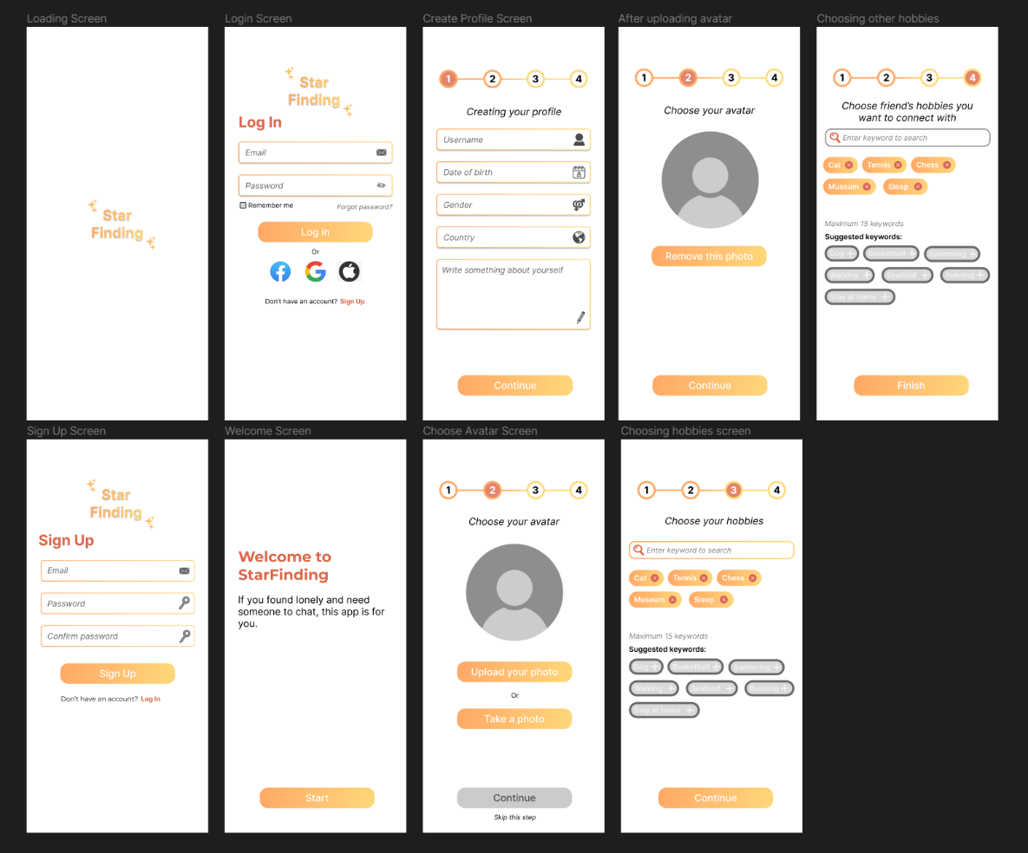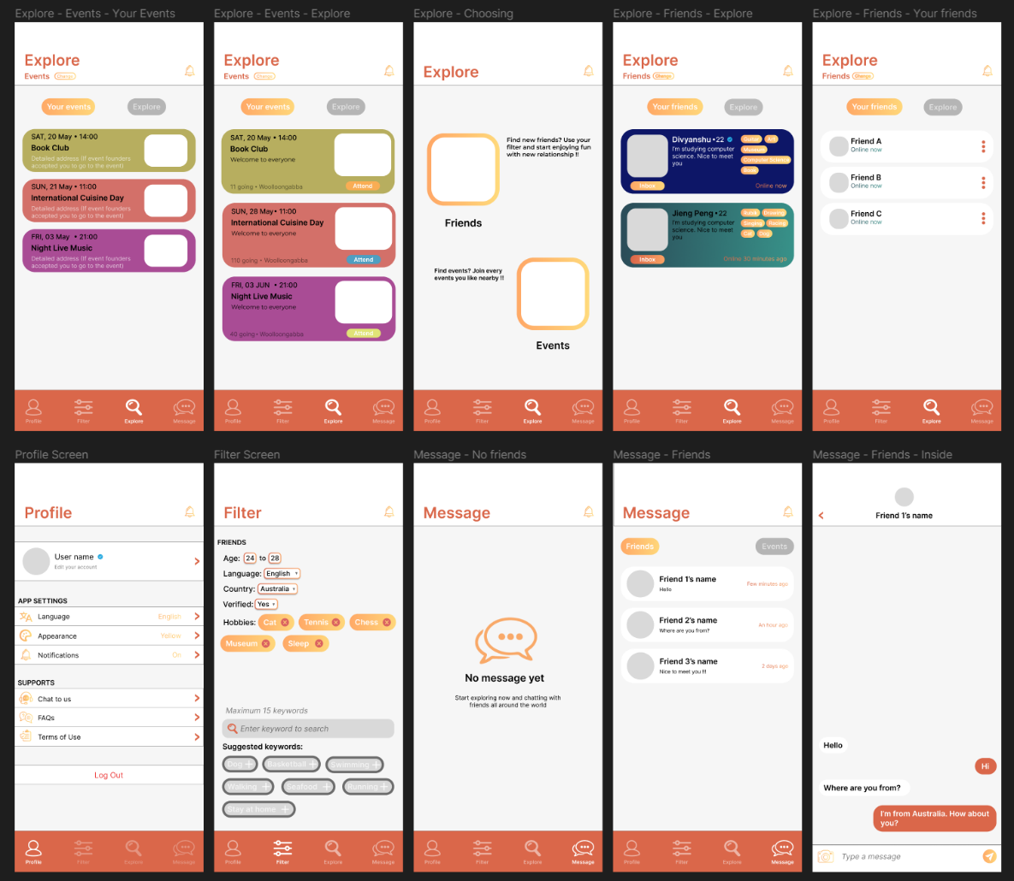

**Figure 29: High-fidelity prototype**

**6. FUTURE DIRECTION**

**6.1 Possible additional features**

One cool additional feature would be adding some AR features to the app. Gamification would be critical to keeping the app's user base, making the user experience fun and engaging. We would want more user testing to make the product more solid. Due to time constraints, we only had two rounds of user testing, which was insufficient for the end product. As a social app, it can access a considerable amount of personal information from users, so it makes sense to research better ways to protect users' information. The surveys showed that many users had concerns about privacy and security. We also need to explore how to make this app more user-friendly. Instead of designing a fancy-looking app, we should strive to develop our app to be user-centric.

**6.2 Possible integration with external services or data**

The app should have a way to integrate with school accounts like UQ identity. The first benefit would be adding a layer of authentication to make the user authentic and trustworthy. The second benefit would be the ease of finding other students in the same university or college. Some people struggled to find teammates for their group projects. Adding the integration to student accounts would help significantly. It will look more like the UQ discord server, but most people in the discord server have a computer science background. Our app aims to change the way people interact with each other.

Another integration would be adding some AI elements. Like the ChatGPT, we could have a chatbot tailoring to users' needs. The user could input their requirements for other users they want to see, like "I would like to make some friends in my DECO3800 class." It would make the friend-finding experience much more efficient and fun. The enhancement of the chatbot would open our app to a more extensive potential user base. Users with weak technical backgrounds would find it easy to communicate with a chatbot rather than go through a long process to set up the app.

**6.3 Future process**

Adding an expert and user-based evaluation would quickly identify our app's weaknesses.

It is essential to prioritise language and cultural support to provide an inclusive experience for users from diverse backgrounds. By implementing advanced functionalities like language translation and culturally sensitive recommendations, the system strives to overcome barriers to communication and understanding. This inclusive approach aims to foster meaningful connections among individuals, irrespective of their languages or cultural disparities. The system's commitment to ensuring that every user feels acknowledged, empathised with, and appreciated creates an environment that promotes genuine connections.

Continued enhancements to the system's matching algorithms would yield significant benefits. The system can offer increasingly precise and pertinent friend recommendations by integrating cutting-edge machine learning and AI methodologies. It would enable users to connect with like-minded individuals who share their interests and hobbies, enhancing their prospects of developing substantial and meaningful friendships.

By incorporating community forums or discussion boards into the system, users can access a dedicated platform for interactive conversations, seeking guidance, and exchanging personal experiences. This valuable addition nurtures a strong user community, facilitating mutual support, forming interest groups, and organising offline meetups. This feature elevates the social dimension of the system, fostering a nurturing and encouraging environment where users can connect and flourish.

**7. TEAMWORK**

## **7.1 Weekly meeting logs**

The details of weekly meeting logs are in the appendix.

## **7.2 Individual reflection**

The details of reflections are in the appendix.

**8. REFERENCE (APA 7th)**

Department of Health and Human Services. (n.d.). *User Research Methods | Usability.gov*. <https://www.usability.gov/how-to-and-tools/methods/user-research/index.html>

Sa, C. (2023, May 27). The UX Design Case Study That Got Me Hired - UX Planet. *Medium*. <https://uxplanet.org/the-ux-design-case-study-that-got-me-hired-c85522cab4ae>

*Likert Scale: Examples and how to use it | SurveyMonkey*. (n.d.). SurveyMonkey. <https://www.surveymonkey.com/mp/likert-scale/>

*What is an Affinity Diagram? K-J Method | ASQ*. (n.d.). <https://asq.org/quality-resources/affinity>

Dam, R. F., & Siang, T. Y. (2023, June 1). Affinity Diagrams: How to Cluster Your Ideas and Reveal Insights. *The Interaction Design Foundation*. <https://www.interaction-design.org/literature/article/affinity-diagrams-learn-how-to-cluster-and-bundle-ideas-and-facts>

Hartson, R., & Pyla, P. S. (2012). UX Book - *Process and Guidelines for Ensuring a Quality User Experience*. Elsevier. https://doi.org/10.1016/C2010-0-66326-7

**9. APPENDIX**

**9.1 Individual reflection**

**9.1.1 Minh Long Vu**

Generally, I planned tasks for team members weekly on Notion. Each week, I read the coursework specification and then read the slides about relevant knowledge, so I could assign tasks to other team members. Another thing I did was write reports and evaluate finished tasks for other team members. The reason why I do this part is that I understand what they were doing, and I also read a lot of Ed Discussion posts, so I could get the latest news about the tasks. I was the person who chose Notion as the app to assign and plan these tasks. However, I think I was wrong when trying to announce other members through Discord after assigning new tasks because we haven’t utilized all features of Notion. Besides, we met lots of problems, which should be talked about in the Team Charter. Some of the problems are: not finishing the tasks, not attending the meeting and studio, dramatically changing the domain, bad task results, and not actively responding in the group chat. I believe that next courses (DECO3801) I will ask the tutor about this before doing the project, which can help me save more time instead of redoing and fixing a lot of times because we cannot apply any punishment to members who violate the rules. Finally, the rest of my parts are designing mid-fidelity and high-fidelity on Figma and writing report documents.

To be more specific, in week 6, we just set up the communication and did the Team Charter. Next, in week 7, I was responsible for researching existing location-sharing apps by introducing, and summarizing the apps, ratings, downloads, etc., analyzing advantages and disadvantages, and finally writing conclusions for 4 applications. We initially chose transacting domain, but one member had a new idea, so we needed to change them due to the result of the voting (3 – 1). This is the first problem we had. The worst case that happened was that 2 members thought the real-time location was a part of transacting. I didn’t understand why we have changed even though others don’t understand the domain we did. Therefore, the result was that I needed to support other members to fix their part. If I had a chance, I would clearly explain the reason why we shouldn’t change as I think we lose too much time on this.

In week 8, I remade the online survey form by using 5-point scale (Likert) questions, which are similar to System Usability Scale (SUS), except that SUS has 10 questions 5 negatives and 5 positives. This is the second problem we met. The reason why I remade this part was because we got feedback from the tutor, and I personally thought that the member doing this part was not spending time to do this. To do this part, I read all the Ed Discussion posts and figured out that I should add scenarios, more choices for each question and categorize questions. Therefore, I split these questions into 3 parts: Understanding the needs and how people think about making new friends, people’s thoughts about the software applications, and ideas about existing applications.

In weeks 9 and 10, I remade the existing apps part due to the change of domains again. This is the third problem we had. One member wanted to add the feature making friends to the app, and they got 2 – 1 voting. After considering, we think the main domain is not sharing location anymore, it should be finding friends, so I need to redid my part – existing apps. However, this time, I read the “UX case that got me hire”, so besides the introduction and conclusion, advantages and disadvantages for the apps, I added feature analysis to compare the features of each app. Therefore, I can target which feature I want in the prototype. In these weeks, I also need to remake the Affinity Diagram by using surveyed data and interviewing notes. I followed 3 steps when creating the Affinity Diagram: writing down all the data we get (raw data), grouping them, and finally labelling them. The reason was that he had one week, but he was still late and he only spent a few minutes on that after the deadline one day; therefore, I personally didn’t trust him to let him redo his part and told him that I did it myself. When writing this individual reflection, I think that I should use voting to decide what should we do in that situation instead of letting myself do others’ parts if they finished badly. It makes the assignment less “teamwork”.

In week 11, I was responsible for doing UX Goals. I read whole chapter 22 of The UX Book to start working on UX Goals and UX Metric. From that chapter, I learned how to create a benchmark task: I followed 8 rules from the books and wrote the benchmark description. I also learned about the connection between UX Goals, UX Measure, Measuring Instruments, and UX Metrics: I followed the example “Buying ticket” from the book and create my own UX Goals and Metrics. Two UX Metrics sI used were: Time on Task and Error Count, which helps me to get the “quick and dirty” quantitative data. The reason why I didn’t use SUS or TAM is because it needs a large amount of data. In addition, I understand how to create Baseline Level, Target Level by experiencing the existing app, which is also my task, I can “guess” these values. This week I also drew the first mid-fidelity prototype on Figma, which only had black and white colour. I used several System Metaphors, combined with Miller’s Law and Hick’s Law during the design progress. Besides, I also followed other existing apps as an example. Finally, after finishing the main functions of the apps. I go to detailed pages like Message – No message, Friend – Current Friend, Event – Your Event, and so on.

In terms of week 12, before the studio class this week, I work on basic navigation of the apps. Finally, I created some interactive components: check box, default-hover-selected icons, input field animations, and options appearance, … Then, in the studio class, I started testing the benchmark test with other members of the group. I also test with my friends outside the class too. Some of the benchmark tests I got the expected level and some I cannot get (most of them are average error tests). Based on the feedback I get through interviewing and observation; I fixed some parts of the mid-fidelity prototype at the end of the week. During this week, I also started writing an interaction flow diagram, explaining my UI (variants, colors, text size, screen size, principle, and so on). The fourth problem we met was the absence of 2 members consecutively from this week. Even though it didn’t affect significantly the progress of the group, it made me feel that they didn’t spend much time on this assignment. The thing I have learned from this situation is that in the meeting, in which we usually only talk about what we should do next week, I should check their progress, and do more activities to make the meeting become more meaningful.

In week 13, we nearly finished the whole work. I prepared the report file, which includes a table of contents and titles, so other team members could work on that. Besides, I was still working on other content of high-fidelity.

Finally, in week 14, after finishing the high-fidelity, I and the other members need to write the introduction and conclusion for the parts we did. These parts are written based on our understanding, and they will support connecting all the progress we have made. Besides, some sentences of introduction for the existing apps I took from the websites, which introduce these apps. I listened to Jiangpeng and removed these sentences from the report to avoid paradigm. The last thing I did for this project was that I formatted the report, imported the meeting logs, and submitted all documents.

In conclusion, I think this course DECO2500 and this assignment helps me a lot with UI and UX. I learned from this assignment about how to create an app, it’s not simple like I think before. I consider this assignment as a case study for myself. Besides, I followed Game Designer, so the knowledge from User Experience helps me a lot about Player Experience, which I think the process is nearly similar. Moreover, knowledge about UI helps me to design the UI of a game. I used to struggle with this, but after studying this course, I think I’m better when designing UI on Figma.

**9.1.2 Jiangpeng Liu**

I oversaw people's work and set deadlines with the help of another team member. One of the problems was that I did not have any ways to enforce the deadline. People were missing the deadlines because they had other homework. We used Notion to track team progress and set deadlines for tasks. If I do this group work assignment again, I would think carefully about developing a mechanism to ensure everyone does their assigned work on time. I designed the deadlines based on the experiences from DECO3801. The problem I identified was that the deadlines would only work the best if every team member strictly followed them. To resolve this problem, we tried to talk with tutors during the tutorials. The outcome was not great because people still missed the deadlines for their parts.

Another problem was low attendance at team meetings. Most meetings would only have two people attending. The lack of communication caused it because people were not replying to the proposed meeting time. It was hard to know people's progress. The meeting time took other team members' schedules in mind, and we tried hard not to meet when one team member had another homework due. This strategy would put the team's progress in an awkward position. Everyone had slightly different deadlines for homework. If I were to do this differently, I would set up the meeting time for the entire project at the beginning of team formation. I would also take notes on their phone numbers, calling them instead of asking them on Discord.

For the contextual inquiry part, I contributed by proposing an initial concept for our project (selecting a domain and identifying an issue). After that, I went through the contextual inquiry by asking people to take user surveys and interviews. Skills I developed in this phase were user testing and interviewing potential user base. After gathering user data, I created a problem statement, user persona, storyboard, and interaction scenario. I developed skills in using relevant tools to create storyboards. The conflict that happened during this phase was that I initially designed the storyboard and user scenario based on the initial low-fidelity prototype. We should develop the prototype based on the storyboard and user scenario, not the other way around. Therefore, I redo the storyboard, user scenario, and low-fidelity prototype. If I were to do this again, I would first do things in the correct order.

I drew a low-fidelity prototype based on the design guidelines and contextual inquiry for the prototype part. If I were to do it differently, I would develop the low-fidelity prototype with professional software instead of pen and paper. The low-fidelity prototype allowed us to get early user feedback and validate our design before transitioning to a high-fidelity prototype. I adapted the design to reflect the results from the survey and interviews better.

I was responsible for "possible additional features" and "possible integration with external services or data" in the future direction section. The writing of future directions took inspiration from our survey and interview data. While writing about the future direction, I researched artificial intelligence, its dangers and bias, and how it would help our product. The integration with AI would be critical since we were creating a system for all age groups. The older generation tends to have difficulties using a new system. The future direction of our project is to evaluate previous work and identify potential weaknesses so we can fix them in the future. If I were to do the future direction differently, I would have more people involved in this part since everyone would have different ideas. It would add diversity to this component. This section of the assignment significantly improved my critical thinking skills.

I was responsible for professionalism, like fixing grammar and checking for plagiarism and AI usage. Going through the report would ensure the consistency and accuracy of the language used. I identified a case where a group member used sentences from external websites and asked the responsible person to redo the part. This process was critical to observe academic integrity and ensure we did not use outside sources without proper citations. If I were to do this part again, I would like to find a proofreader who had never seen our report to evaluate it. Because we were familiar with the project, we might fill the gap in our brain like Gestalt's Theory when dealing with incomplete images. Therefore, having an outside proofreader would pick up the mistakes we overlooked.

In conclusion, I gained many valuable design, research, and testing skills and identified weaknesses in my teamwork strategies. It would be beneficial for my future group assignments.

**9.1.3 Varun Singh**

In completing the assignment, I made noteworthy contributions to the team's collective effort. My responsibilities encompassed diverse facets of the project, such as the interaction paradigm, interaction mode, and the high-level system description. I actively engaged in conducting interviews, refining interview questions, and synthesizing the acquired data. Moreover, I played a pivotal role in charting the course for future project developments.

My involvement centred on extensive research and analysis of pertinent elements related to the interaction paradigm. This involved meticulous evaluation of various models and frameworks, taking into account user requirements and system constraints. By contributing to the decision-making process, I ensured that the chosen interaction paradigm aligned harmoniously with the overarching goals and objectives of our project.

Collaborating closely with my team members, we deliberated on different interaction modes to identify the most optimal choice for our system. Through productive discussions and brainstorming sessions, we methodically assessed the merits and demerits of each mode. Drawing upon insights from user preferences and technological considerations, I provided invaluable input in selecting an interaction mode that would facilitate an intuitive and efficient user experience. Furthermore, I actively contributed to outlining specific functionalities and features associated with the selected interaction mode, which seamlessly integrated into the final system design.

To foster effective collaboration within the team, I consistently encouraged open and constructive communication amongst members. Regular progress updates were actively sought, and a supportive environment was cultivated, ensuring that everyone had the opportunity to voice their opinions and concerns. In instances where conflicts emerged, I advocated for a solution-oriented approach, emphasizing empathy, active listening, and respectful dialogue. By nurturing a positive team dynamic, we adeptly managed and resolved conflicts, maintaining a cohesive and productive working environment.

Reflecting on my contributions, there are areas where I would approach future projects differently. Specifically, I would prioritize inclusive decision-making processes that actively involve all team members, particularly during the selection of interaction paradigms and modes. By fostering a collective decision-making approach, the diverse expertise and perspectives of team members can be effectively harnessed.

I have gained immeasurable value from this assignment, as it has been instrumental in honing my teamwork strategies and abilities. It has afforded me numerous chances to fine-tune my research and analytical skills, expand my comprehension of interaction design principles, and enhance my capacity to communicate and collaborate seamlessly with my team members. The knowledge and expertise acquired through this assignment will undoubtedly provide a robust groundwork for my forthcoming projects. Looking ahead, I am resolute in my commitment to consistently apply these skills, recognizing the paramount importance of cultivating an inclusive and harmonious team environment in every pursuit.

### **9.1.4 Divyanshu**

In the following assignment, I made significant contributions to the team effort and actively ensured its successful completion. I would love to reflect on my contributions, how they fit into the bigger picture of the assessment, and what I would do differently in future collaborations.

Migrating to a different country and finding people to interact with is always difficult for certain people to overcome the specified problem my teammates assigned and choose specific tasks that can help us target this issue and design an application for it. I selected the survey part, which shapes our application's design proposal towards the problems people face. I created a draft survey and discussed the questions with my teammates, which helped me make the survey as concise as possible. The next significant part of our design proposal was conducting the online survey and making notes for the affinity diagram. After making the affinity diagram through interviews and survey questions, we focused on conceptual design. I aimed to provide a strong foundation for our team's work by dedicating significant time and effort to this research phase.

In conceptual design, we outline the fundamental ideas of our design. After my teammate created the persona by the interview, most of my focus was on extracting the problem statement and creating metaphors (system, interaction & interface) which perfectly aligned with our future discussion about the application design. Different metaphors and the system concept statement laid the foundation for our first prototype, which we designed.

To promote successful involvement, we focused on meeting physically rather than using online platforms. In the last few weeks, I have been suffering from a fever and throat infection and could not meet my teammates physically, but we were regularly in contact and made frequent communication for the work update. Whenever any conflicts emerged, we physically met and listened to each other problems regarding work updates while promoting respectful communication strategies.

In conclusion, my work centred on researching and developing meaningful system concept statements, and my teammates' collective efforts helped design the prototype. The following assignment helped me develop valuable teamwork skills and showed me how the work is completed on a bigger scale.

**9.2 Meeting Logs**

**Date:** 8/4/2023

**Teaching Week/Studio #:** 6 (Off-week studio)

**Team Name:** Alphabet

**Team members present**

Jiangpeng Liu, Varun Singh, Divyanshu, Minh Long Vu

**Items discussed and worked on from the previous week**

*Including their current state (e.g., not started, in progress, completed, etc.) and team member allocation.*

|  |  |  |  |
| --- | --- | --- | --- |
| **Item** | **Current State** | **Team Member(s) Responsible** | **Notes** |
| Team charter | Completed | Everyone |  |
| Task Management | Completed | Everyone |  |
| Create team schedule | Completed | Everyone |  |

**Issues That Arose**

- Online meeting is not working as each of us has own problems (microphone, wifi, noise,…)

**Actions Required**

- Decide to have offline meeting on next day (8/4/2023)

**Deliverables to be completed by the next week, including plan**

*Including team member allocation to tasks/deliverables*

|  |  |  |  |
| --- | --- | --- | --- |
| **Item** | **Due Date** | **Team Member(s) Responsible** | **Notes** |
| Creating question for interviewing | 18/3/2023 | Varun Singh |  |
| Research existing apps | 18/3/2023 | Minh Long Vu |  |
| Conduct online survey | 18/3/2023 | Divyanshu |  |
| Draw low-fidelity prototype | 18/3/2023 | Jiangpeng |  |
| Interviewing people | 18/3/2023 | Everyone |  |

**Other Comments**

* Interviewing people will be conducted lastly because we need to have a draft, questions for interviewing, general problems with exisiting app and data of survey to interview detailedly.

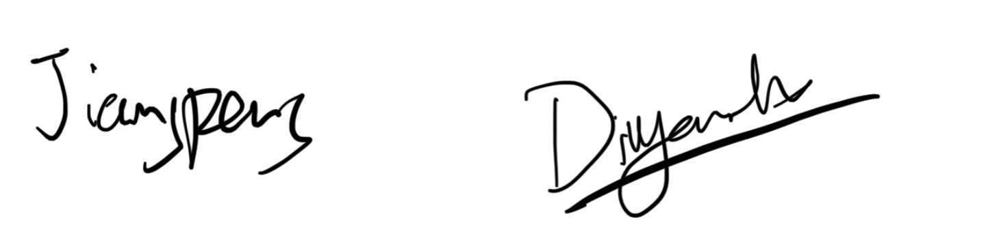**Signed and Accepted**



**Minh Long Vu**

**Jiangpeng Liu**

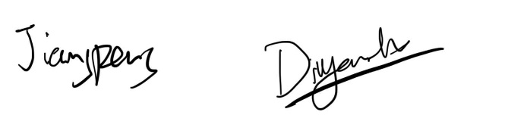

**Divyanshu**

**Varun Singh**

**Date:** 28/3/2023

**Teaching Week/Studio #:** 6

**Team Name: Alphabet**

**Team members present**

Jiangpeng Liu, Varun Singh, Divyanshu, Minh Long Vu

**Items discussed and worked on from the previous week**

*Including their current state (e.g., not started, in progress, completed, etc.) and team member allocation.*

|  |  |  |  |
| --- | --- | --- | --- |
| **Item** | **Current State** | **Team Member(s) Responsible** | **Notes** |
| Team Charter | In progress | Everyone |  |
| Set up communication | Completed | Everyone |  |
| Task management (Notion) | In progress | Everyone |  |
| Create team schedule | Not started | Everyone |  |

**Issues That Arose**

**Actions Required**

**Deliverables to be completed by the next week, including plan**

*Including team member allocation to tasks/deliverables*

|  |  |  |  |
| --- | --- | --- | --- |
| **Item** | **Due Date** | **Team Member(s) Responsible** | **Notes** |
| Team Charter | 28-3-2023 | Everyone |  |
| Task management (Notion) | 31-3-2023 | Everyone |  |
| Create team schedule | 4-4-2023 | Everyone |  |

**Other Comments**

**Signed and Accepted**





**Minh Long Vu**

**Jiangpeng Liu**





**Varun Singh**

**Divyanshu**

**Date:** 18-4-23

**Teaching Week/Studio #:** 7

**Team Name:** Alphabet

**Team members present**

Jiangpeng Liu, Varun Singh, Minh Long Vu

**Items discussed and worked on from the previous week**

*Including their current state (e.g., not started, in progress, completed, etc.) and team member allocation.*

|  |  |  |  |
| --- | --- | --- | --- |
| **Item** | **Current State** | **Team Member(s) Responsible** | **Notes** |
| Creating question for interviewing | Completed | Varun Singh |  |
| Research existing apps | Completed | Minh Long Vu |  |
| Conduct online survey form | In progress | Divyanshu |  |
| Draw low-fidelity prototype | Completed | Jiangpeng |  |
| Interviewing people | In progress | Everyone |  |

**Issues That Arose**

* We initially choosed transacting. However, then one member had a new idea (finding people location indoor, e.g inside the building, and it can detect the level of floor we are in compared to partners) => Interview questions and online survey parts need to be fixed.
* Divyanshu and Varun Singh didn’t notice that change, they think sharing location is a part of transacting, so that is the reason why the part they do need to be fix.

**Actions Required**

* We support other team members to make it faster.

**Deliverables to be completed by the next week, including plan**

*Including team member allocation to tasks/deliverables*

|  |  |  |  |
| --- | --- | --- | --- |
| **Item** | **Due Date** | **Team Member(s) Responsible** | **Notes** |
| Interview 12 people | 23/4/23 | Everyone |  |
| Conduct online survey (100 people) | 25/4/23 | Everyone | After the form finish |
| Do Affinity diagram | 2/5/23 | Divyanshu | After interviewing and collecting enough data form survey |
| Draw detailed low-fidelity prototype | 29/4/23 | Jiangpeng |  |
| Redo existing app | 2/5/23 | Minh Long Vu | Due to change of domains |

**Other Comments**

**Signed and Accepted**





**Minh Long Vu**

**Jiangpeng Liu**



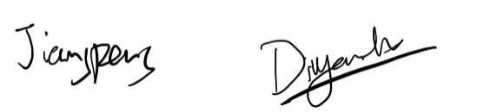

**Varun Singh**

**Divyanshu**

**Date:** 22-4-23

**Teaching Week/Studio #:** 8

**Team Name:** Alphabet

**Team members present**

Jiangpeng Liu, Minh Long Vu

**Items discussed and worked on from the previous week**

*Including their current state (e.g., not started, in progress, completed, etc.) and team member allocation.*

|  |  |  |  |
| --- | --- | --- | --- |
| **Item** | **Current State** | **Team Member(s) Responsible** | **Notes** |
| Conduct online survey form | Completed | Divyanshu |  |
|  |  |  |  |
| Interview 12 people | In progress | Everyone |  |
| Conduct online survey (100 people) | In progress | Everyone |  |
| Do Affinity diagram | Not started | Divyanshu | Will start after interviewing and collecting enough data form survey |
| Draw detailed low-fidelity prototype (with some settings, some basic features) | In progress | Jiangpeng |  |
| Redo the research of existing app | In progress | Minh Long Vu | due to our main domain is changed |

**Issues That Arose**

- Varun Sigh cannot go to the meeting because he has fever and little cold.

- Zenith cannot go to the meeting due to the bus doesn’t arrive.

- We change our domain second time because we realize that between share real-time location to make new friends, the make new friends part is more important => Research existing apps need to change to 3 other apps involve in finding friends instead of real-time sharing location.

- We get the feedback of the teacher about the survey form, which needs to be improve.

**Actions Required**

- Long will be responsible for redoing the survey form because we need to be hurry in this part.

- Jiangpeng and Long fix some parts of the interview questions due to changing our domain to friend finding.

- We assigned the tasks on Notion and notified team members on Discord

**Deliverables to be completed by the next week, including plan**

*Including team member allocation to tasks/deliverables*

|  |  |  |  |
| --- | --- | --- | --- |
| **Item** | **Due Date** | **Team Member(s) Responsible** | **Notes** |
| Interview 12 people | 29/4/23 | Everyone |  |
| Conduct online survey (100 people) | 29/4/23 | Everyone |  |
| Do Affinity diagram | 2/5/23 | Divyanshu | After interviewing and collecting enough data form survey |
| Draw detailed low-fidelity prototype | 2/5/23 | Jiangpeng |  |
| Redo the research of existing app | 2/5/23 | Minh Long Vu | due to our main domain is changed |

**Other Comments**

**Signed and Accepted**





**Minh Long Vu**

**Jiangpeng Liu**



**Varun Singh**

**Divyanshu**

**Date:** 2-5-23

**Teaching Week/Studio #:** 10

**Team Name:** Alphabet

**Team members present**

Jiangpeng Liu, Minh Long Vu, Varun Sigh

**Items discussed and worked on from the previous week**

*Including their current state (e.g., not started, in progress, completed, etc.) and team member allocation.*

|  |  |  |  |
| --- | --- | --- | --- |
| **Item** | **Current State** | **Team Member(s) Responsible** | **Notes** |
| Interview 12 people | Completed | Everyone |  |
| Conduct online survey (100 people) | Completed | Everyone |  |
| Do Affinity diagram | In progress | Divyanshu |  |
| Draw detailed low-fidelity prototype | Completed | Jiangpeng |  |
| Redo the research of existing app | Completed | Minh Long Vu |  |

**Issues That Arose**

- Jiangpeng Liu finds it hard to get some friends to do the apps for him because he comes from China, where people cannot access Google there.

- Divyanshu hasn’t finished his tasks yet. He promised to finish it next day.

- Divyanshu doesn’t attend the studio today because he has a meeting with Associate Dean.

**Actions Required**

**­-** Other members need to invite more to get the target number of people do the survey.

- Communicated with team member for missing deadline.

**Deliverables to be completed by the next week, including plan**

*Including team member allocation to tasks/deliverables*

|  |  |  |  |
| --- | --- | --- | --- |
| **Item** | **Due Date** | **Team Member(s) Responsible** | **Notes** |
| Do Affinity diagram | 3/5 | Divyanshu |  |
| Drawing story board | 20/5 | Minh Long Vu |  |
| Write user persona |  |
| Interaction senarios |  |
| Interaction paradigm | 20/5 | Varun Singh |  |
| Interaction Mode |  |
| High Description for system work |  |
| UX Goals | 20/5 | Jiangpeng |  |
| Metrics |  |
| Drawing on Figma |  |
| Problem Statement | 20/5 | Divyanshu |  |
| Metaphors (system, interation & interface) |  |

**Other Comments**

**Signed and Accepted**





**Minh Long Vu**

**Jiangpeng Liu**



**Divyanshu**

**Varun Singh**

**Date:** 6/5/2023

**Teaching Week/Studio #:** 10

**Team Name: Alphabet**

**Team members present**

Jiangpeng Liu, Varun Singh, Divyanshu, Minh Long Vu

**Items discussed and worked on from the previous week**

*Including their current state (e.g., not started, in progress, completed, etc.) and team member allocation.*

|  |  |  |  |
| --- | --- | --- | --- |
| **Item** | **Current State** | **Team Member(s) Responsible** | **Notes** |
| Do Affinity diagram | Completed but need improve | Divyanshu |  |
| Completed | Minh Long Vu |  |
| Drawing story board | Not started | Jiangpeng | Change the team member doing the tasks |
| Write user persona |
| Interaction senarios |
| Interaction paradigm | Not started | Varun Singh |  |
| Interaction Mode |
| High Description for system work |
| UX Goals | Not started | Minh Long Vu | Change the team member doing the tasks |
| Metrics |
| Drawing on Figma |
| Problem Statement | Not started | Divyanshu |  |
| Metaphors (system, interation & interface) |

**Issues That Arose**

* Divyanshu don’t know how to separate the data. Besides, he did it through Word, so the affinity diagram he does is little bit hard to understand.
* Jiangpeng struggled when drawing on Figma.

**Actions Required**

* Because we are in hurry, Long is assigned to redo the affinity diagram within weekdays because he is free this week.
* Long and Jiangpeng swaped their tasks because Long has more experience on Adobe Illustrator, which is similar to Figma, before.

**Deliverables to be completed by the next week, including plan**

*Including team member allocation to tasks/deliverables*

|  |  |  |  |
| --- | --- | --- | --- |
| **Item** | **Due Date** | **Team Member(s) Responsible** | **Notes** |
| Drawing story board | 20/5 | Jiangpeng |  |
| Write user persona |  |
| Interaction senarios |  |
| Interaction paradigm | 20/5 | Varun Singh |  |
| Interaction Mode |  |
| High Description for system work |  |
| UX Goals | 20/5 | Minh Long Vu |  |
| Metrics |  |
| Drawing on Figma |  |
| Problem Statement | 20/5 | Divyanshu |  |
| Metaphors (system, interation & interface) |  |
| Prepare report file (Table of contents) for others write their part on that | 27/5 | Minh Long Vu |  |

**Other Comments**

**Signed and Accepted**





**Minh Long Vu**

**Jiangpeng Liu**



**Varun Singh**

**Divyanshu**

**Date:** 9/5/2023

**Teaching Week/Studio #:** 11

**Team Name: Alphabet**

**Team members present**

Jiangpeng Liu, Varun Singh, Minh Long Vu

**Items discussed and worked on from the previous week**

*Including their current state (e.g., not started, in progress, completed, etc.) and team member allocation.*

|  |  |  |  |
| --- | --- | --- | --- |
| **Item** | **Current State** | **Team Member(s) Responsible** | **Notes** |
| Drawing story board | Not started | Jiangpeng | Change the team member doing the tasks |
| Write user persona |
| Interaction senarios |
| Interaction paradigm | Not started | Varun Singh |  |
| Interaction Mode |
| High Description for system work |
| UX Goals | Not started | Minh Long Vu | Change the team member doing the tasks |
| Metrics |
| Drawing on Figma |
| Problem Statement | Not started | Divyanshu |  |
| Metaphors (system, interation & interface) |
| Prepare report file (Table of contents) for others write their part on that | Not started | Minh Long Vu |  |

**Issues That Arose**

* Divyanshu doesn’t attend the studio because he had an assignment today and he had been awake the whole night working on that.

**Actions Required**

- Communicated with Divyanshu about his tasks on Discord

**Deliverables to be completed by the next week, including plan**

*Including team member allocation to tasks/deliverables*

|  |  |  |  |
| --- | --- | --- | --- |
| **Item** | **Due Date** | **Team Member(s) Responsible** | **Notes** |
| Drawing story board | 16/5 | Jiangpeng |  |
| Write user persona |  |
| Interaction senarios |  |
| Interaction paradigm | 16/5 | Varun Singh |  |
| Interaction Mode |  |
| High Description for system work |  |
| UX Goals | 16/5 | Minh Long Vu |  |
| Metrics |  |
| Drawing on Figma |  |
| Problem Statement | 16/5 | Divyanshu |  |
| Metaphors (system, interation & interface) |  |
| Prepare report file (Table of contents) for others write their part on that | 27/5 | Minh Long Vu |  |

**Other Comments**

**Signed and Accepted**





**Minh Long Vu**

**Jiangpeng Liu**



**Divyanshu**

**Varun Singh**

**Date: 1**6/5/2023

**Teaching Week/Studio #:** 12

**Team Name: Alphabet**

**Team members present**

Jiangpeng Liu, Minh Long Vu

**Items discussed and worked on from the previous week**

*Including their current state (e.g., not started, in progress, completed, etc.) and team member allocation.*

|  |  |  |  |
| --- | --- | --- | --- |
| **Item** | **Current State** | **Team Member(s) Responsible** | **Notes** |
| Drawing story board | Completed | Jiangpeng | Change the team member doing the tasks |
| Write user persona |
| Interaction senarios |
| Interaction paradigm | In progress | Varun Singh |  |
| Interaction Mode |
| High Description for system work |
| UX Goals | Completed | Minh Long Vu | Change the team member doing the tasks |
| Metrics |
| Drawing on Figma |
| Problem Statement | In progress | Divyanshu |  |
| Metaphors (system, interation & interface) |
| Prepare report file (Table of contents) for others write their part on that | In progress | Minh Long Vu |  |

**Issues That Arose**

* Divyanshu doesn’t attend the studio because he has overslept. He has finished his task but hasn’t uploaded it to Notion. He promised to upload it after few hours.
* Varun Singh hasn’t attended the studio and hasn’t finished his task, he promises to post it after few hours.

**Actions Required**

* Tasks were posted on Notion for team members who missed studio. We also mention about the task in Discord in case that they don’t notice the new task.
* We communicated with tutors on team members who repeatedly missed studio and team meetings.

**Deliverables to be completed by the next week, including plan**

*Including team member allocation to tasks/deliverables*

|  |  |  |  |
| --- | --- | --- | --- |
| **Item** | **Due Date** | **Team Member(s) Responsible** | **Notes** |
| Prepare report file (Table of contents) for others write their part on that | 27/5 | Minh Long Vu |  |
| Write introduction, and conclusion to show understand of their part | 31/5 | Everyone |  |
| Explain UI/UX and doing high-fidelity prototype | 31/5 | Minh Long Vu |  |
| Upload Individual Reflection | 31/5 | Everyone |  |
| Writing future direction | 31/5 | Varun Singh, Jiangpeng Liu |  |
| Format the report file after all the tasks are finish | 3/6 | Minh Long Vu |  |

**Other Comments**

**Signed and Accepted**





**Minh Long Vu**

**Jiangpeng Liu**



**Varun Singh**

**Divyanshu**

**Date:** 20/5/2023

**Teaching Week/Studio #:** 12

**Team Name: Alphabet**

**Team members present**

Jiangpeng Liu, Minh Long Vu

**Items discussed and worked on from the previous week**

*Including their current state (e.g., not started, in progress, completed, etc.) and team member allocation.*

|  |  |  |  |
| --- | --- | --- | --- |
| **Item** | **Current State** | **Team Member(s) Responsible** | **Notes** |
| Prepare report file (Table of contents) for others write their part on that | In progress | Minh Long Vu |  |
| Write introduction, and conclusion to show understand of their part | In progress | Everyone |  |
| Explain UI/UX and doing high-fidelity prototype | In progress | Minh Long Vu |  |
| Upload Individual Reflection | In progress | Everyone |  |
| Writing future direction | In progress | Varun Singh, Jiangpeng Liu |  |

**Issues That Arose**

* Divyanshu doesn’t attend the meeting because he has a pitch preparation today and Sunday for his ENGG4900 course.
* Varun Singh is busy with his 2002 assignment so he can’t come.

**Actions Required**

* Tasks posted on Notion and remind them through Discord.

**Deliverables to be completed by the next week, including plan**

*Including team member allocation to tasks/deliverables*

|  |  |  |  |
| --- | --- | --- | --- |
| **Item** | **Due Date** | **Team Member(s) Responsible** | **Notes** |
| Prepare report file (Table of contents) for others write their part on that | 27/5 | Minh Long Vu |  |
| Write introduction, and conclusion to show understand of their part | 31/5 | Everyone |  |
| Explain UI/UX and doing high-fidelity prototype | 31/5 | Minh Long Vu |  |
| Upload Individual Reflection | 31/5 | Everyone |  |
| Writing future direction | 27/5 | Varun Singh, Jiangpeng Liu |  |
| Format the report document | 2/6 | Minh Long Vu |  |
| Checking grammar | 1/6 | Jiangpeng Liu |  |

**Other Comments**

**Signed and Accepted**





**Minh Long Vu**

**Jiangpeng Liu**



**Varun Singh**

**Divyanshu**

**Date:** 27/5/2023

**Teaching Week/Studio #:** 13

**Team Name: Alphabet**

**Team members present**

JiangPeng Liu, Minh Long Vu

**Items discussed and worked on from the previous week**

*Including their current state (e.g., not started, in progress, completed, etc.) and team member allocation.*

|  |  |  |  |
| --- | --- | --- | --- |
| **Item** | **Current State** | **Team Member(s) Responsible** | **Notes** |
| Prepare report document for others to edit | Complete | Minh Long Vu |  |
| Format report document | In progress |  |
| Doing High-fidelity prototype and explain UI. | In progress |  |
| Writing about future direction | In progress | Jiangpeng Liu,  Varun Singh | Varun Sigh haven’t done yet. Jiangpeng Liu has already done |
| Upload to Notion: Individual Reflection | In progress | Everyone |  |
| Writing introduction, linking paragraph and conclusion of each part based on each team member understading | In progress |  |
| Checking grammar | In progress | Jiangpeng Liu |  |

**Issues That Arose**

* Divyanshu doesn’t attend because of having assignment today.
* Varun Singh doesn’t attend because of having assignment on Monday. He also doesn’t finish his parts Future Direction yet.

**Actions Required**

* Allow Varun Singh to have an extent deadline on Tuesday 30th, May.

**Deliverables to be completed by the next week, including plan**

*Including team member allocation to tasks/deliverables*

|  |  |  |  |
| --- | --- | --- | --- |
| **Item** | **Due Date** | **Team Member(s) Responsible** | **Notes** |
| Format report document | 2/6 | Minh Long Vu |  |
| Doing High-fidelity prototype and explain UI. | 31/5 |  |
| Writing about future direction | 30/5 | Varun Singh |  |
| Upload to Notion: Individual Reflection | 31/5 | Everyone |  |
| Writing introduction, linking paragraph and conclusion of each part based on each team member understading | 31/5 | Everyone |  |
| Checking grammar | 1/6 | Jiangpeng Liu |  |

**Other Comments**

**Signed and Accepted**





**Minh Long Vu**

**Jiangpeng Liu**



**Varun Singh**

**Divyanshu**

**Date:** 30/5/2023

**Teaching Week/Studio #:** 14 (No studio this week)

**Team Name: Alphabet**

**Team members present**

JiangPeng Liu, Varun Singh, Divyanshu, Minh Long Vu

**Items discussed and worked on from the previous week**

*Including their current state (e.g., not started, in progress, completed, etc.) and team member allocation.*

|  |  |  |  |
| --- | --- | --- | --- |
| **Item** | **Current State** | **Team Member(s) Responsible** | **Notes** |
| Format report document | In progress | Minh Long Vu |  |
| Doing High-fidelity prototype and explain UI. | In progress |  |
| Writing about future direction | Completed | Jiangpeng Liu  Varun Sigh |  |
| Upload to Notion: Individual Reflection | In progress | Everyone |  |
| Writing introduction, linking paragraph and conclusion of each part based on each team member understading | In progress | Divyanshu has finished his part |
| Checking grammar | In progress | Jiangpeng Liu |  |

**Issues That Arose**

* Varun Sigh didn’t finish “Future Direction” before the meeting. He finished it before the meeting ended.

**Actions Required**

**Deliverables to be completed by the next week, including plan**

*Including team member allocation to tasks/deliverable*

|  |  |  |  |
| --- | --- | --- | --- |
| **Item** | **Due Date** | **Team Member(s) Responsible** | **Notes** |
| Format report document | 2/6 | Minh Long Vu |  |
| Doing High-fidelity prototype and explain UI. | 31/5 |  |
| Upload to Notion: Individual Reflection | 31/5 | Everyone |  |
| Writing introduction, linking paragraph and conclusion of each part based on each team member understading | 31/5 | Everyone | Divyanshu has finished his part |
| Checking grammar | 1/6 | Jiangpeng Liu |  |

**Other Comments**

**Signed and Accepted**





**Minh Long Vu**

**Jiangpeng Liu**



**Divyanshu**

**Varun Singh**

**Date:** 1/6/2023

**Teaching Week/Studio #:** 14 (No studio this week)

**Team Name: Alphabet**

**Team members present**

JiangPeng Liu, Varun Singh, Minh Long Vu

**Items discussed and worked on from the previous week**

*Including their current state (e.g., not started, in progress, completed, etc.) and team member allocation.*

|  |  |  |  |
| --- | --- | --- | --- |
| **Item** | **Current State** | **Team Member(s) Responsible** | **Notes** |
| Format report document | Completed | Minh Long Vu |  |
| Doing High-fidelity prototype and explain UI. | Completed |  |
| Writing about future direction | Completed | Jiangpeng Liu  Varun Sigh |  |
| Upload to Notion: Individual Reflection | Completed | Everyone |  |
| Writing introduction, linking paragraph and conclusion of each part based on each team member understading | Completed |  |
| Checking grammar | Completed | Jiangpeng Liu |  |

**Issues That Arose**

* Divyanshu doesn’t attend the meeting and not respond to the messages. Besides, he also doesn’t submit his individual reflection. There is also one part that he hasn’t finished, but he didn’t respond so Jiangpeng did his part.

**Actions Required**

- We post the questions on Ed Discussion. And we also let him submit individual reflection by himself.

- We also sent an email to the course mailbox, and we notified the team member on DIscord multiple times

**Deliverables to be completed by the next week, including plan**

*Including team member allocation to tasks/deliverable*

|  |  |  |  |
| --- | --- | --- | --- |
| **Item** | **Due Date** | **Team Member(s) Responsible** | **Notes** |

**Other Comments**

- Divyanshu finally responded on Friday night saying he had “high fever and allergic reaction. He also added his individual reflection to the report. We will do a final submission on Sunday night.

**Signed and Accepted**





**Minh Long Vu**

**Jiangpeng Liu**





**Varun Singh**

**Divyanshu**

**9.3 Interviewing notes**

### **9.3.1 Interview questions**

These are some questions we have prepared for interviewing in case that we need ideas to ask.

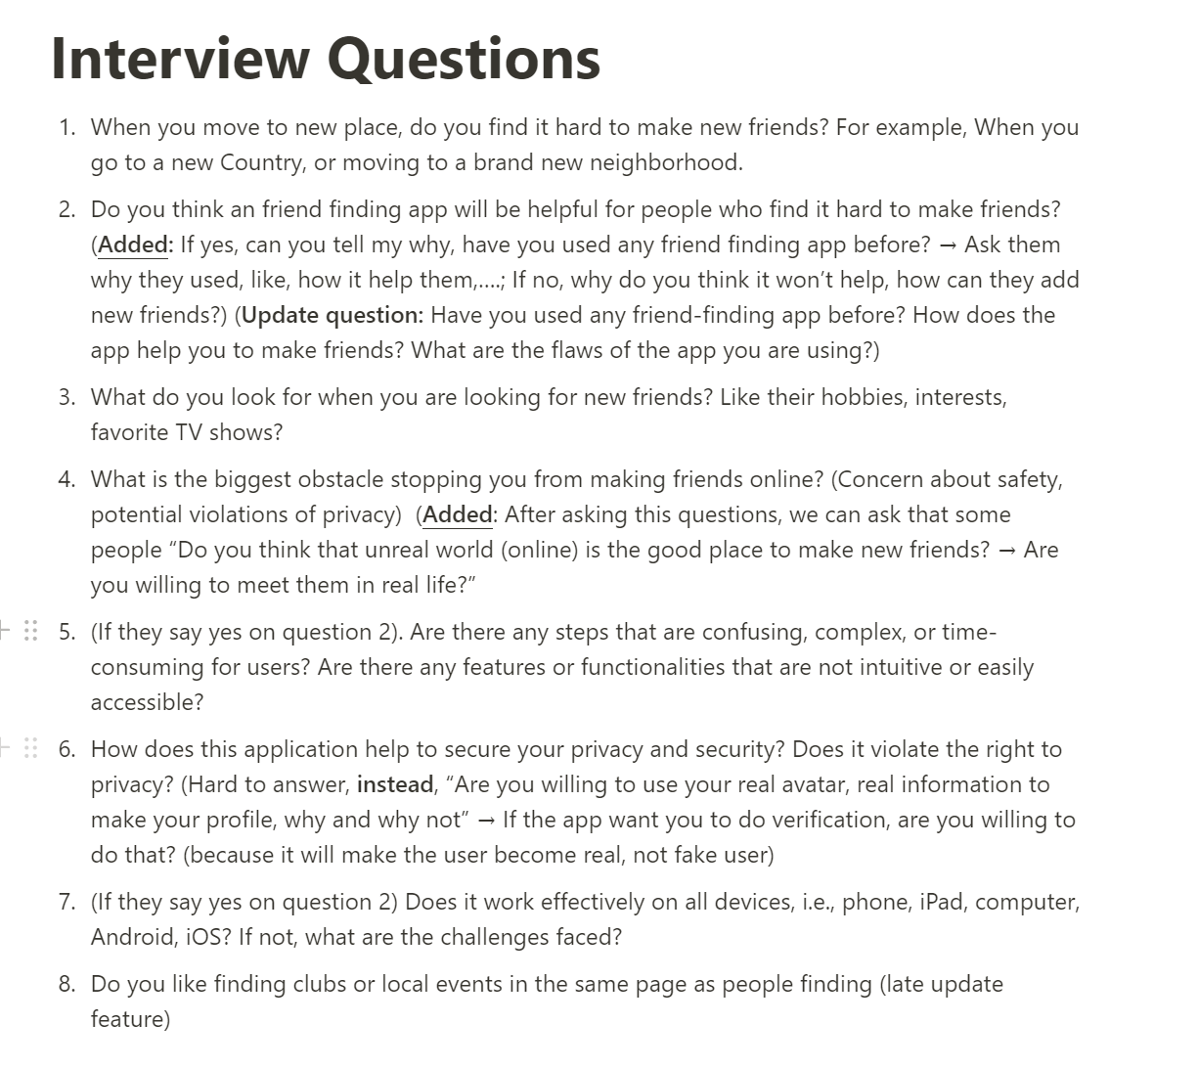

### **9.3.2 Interview responses**

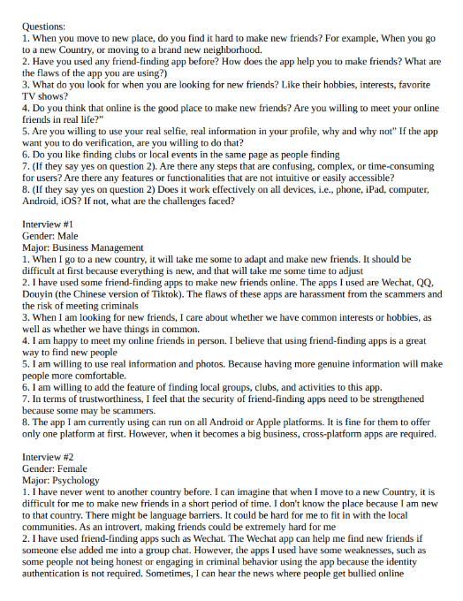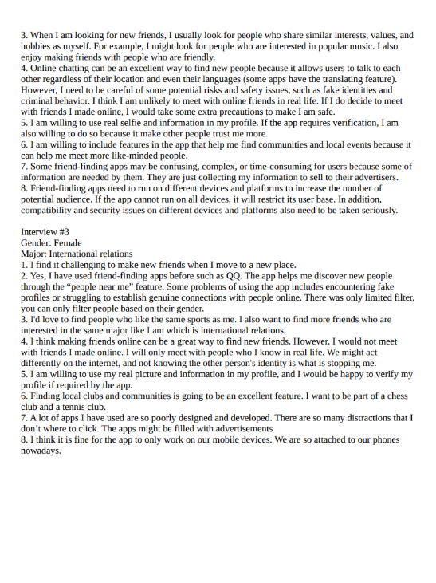

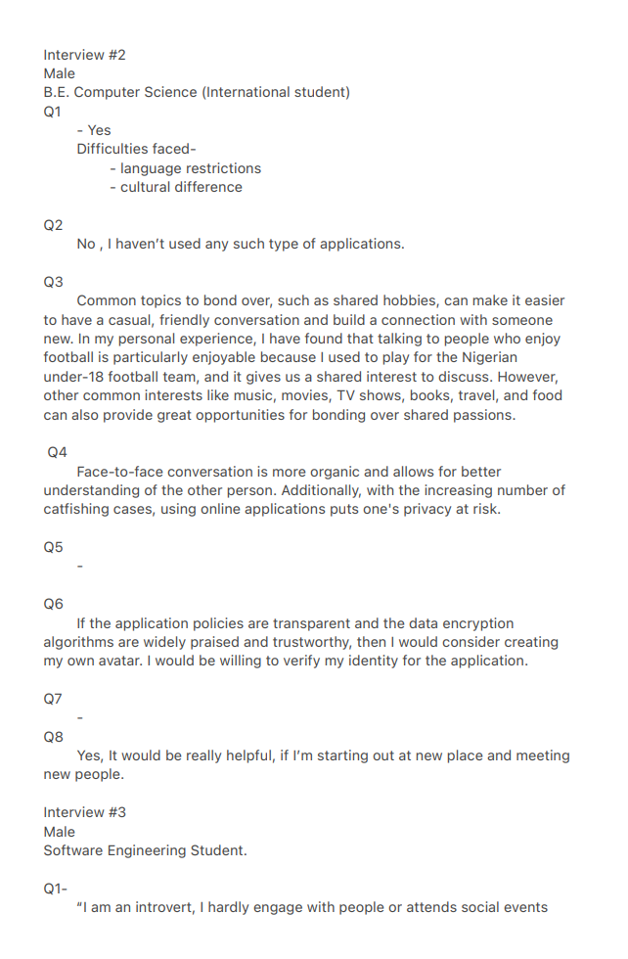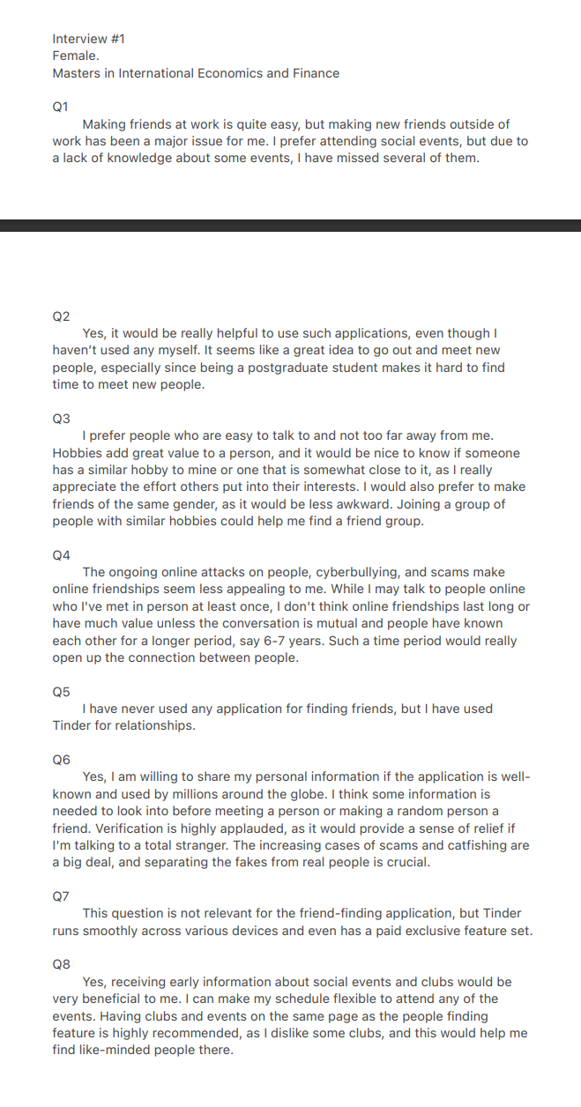

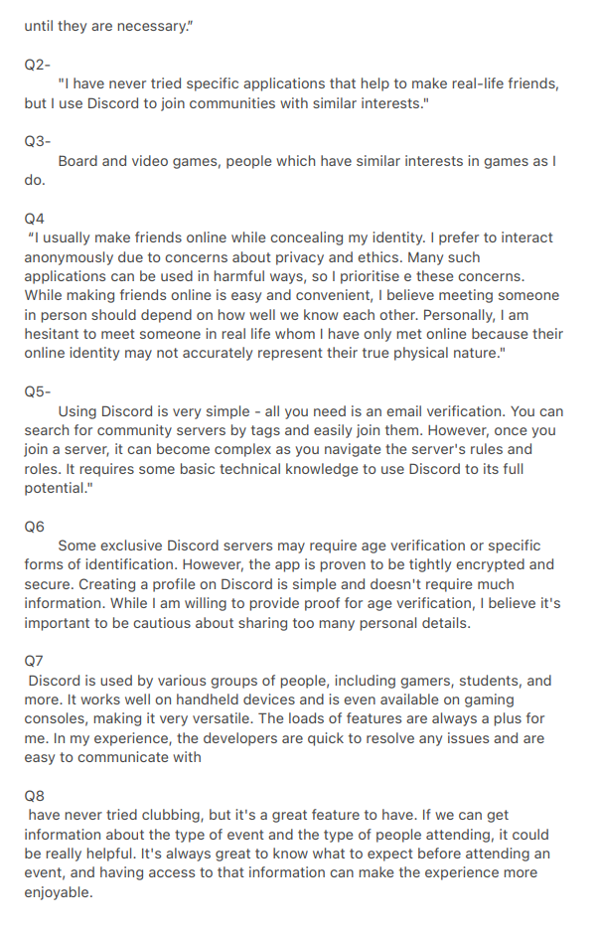

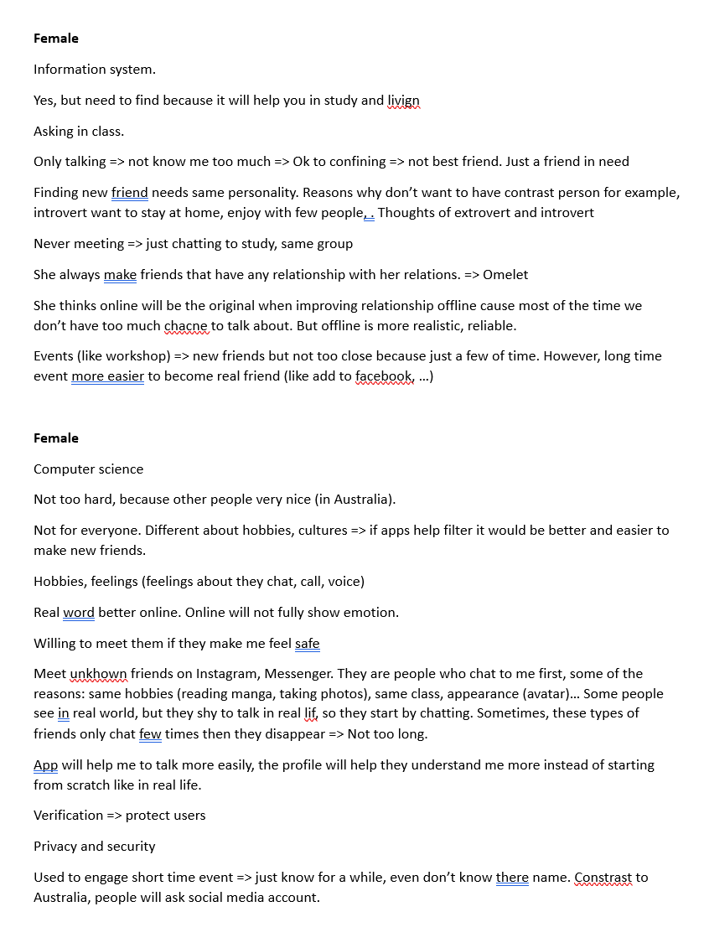

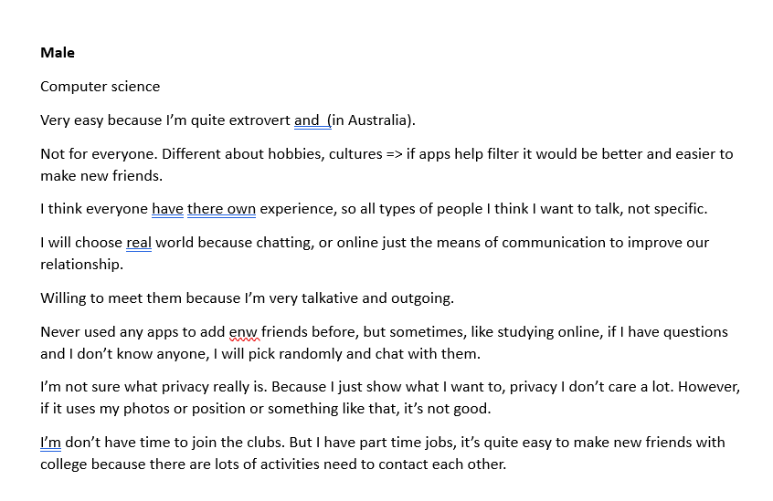

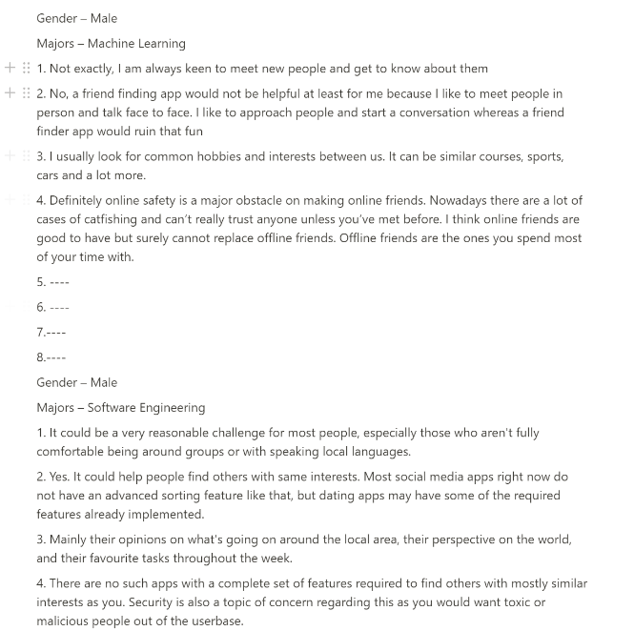

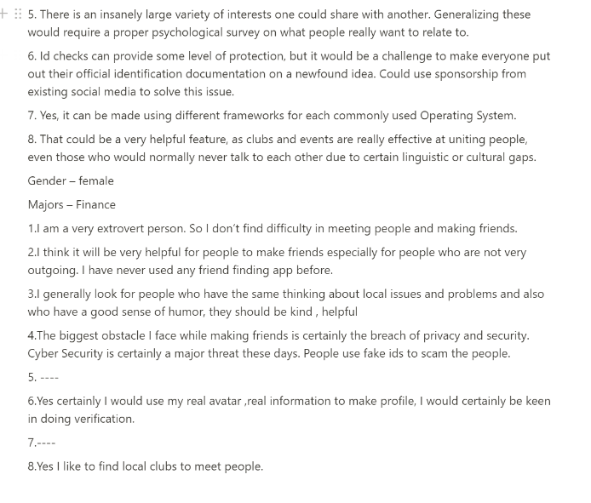

## **9.4 Survey summary**

### **9.4.1 Interview questions**

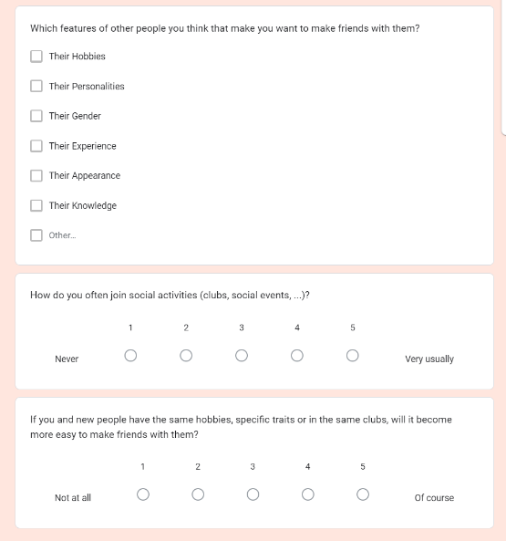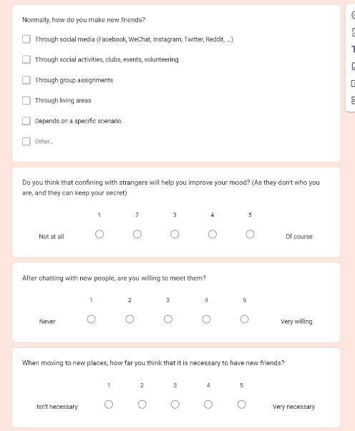

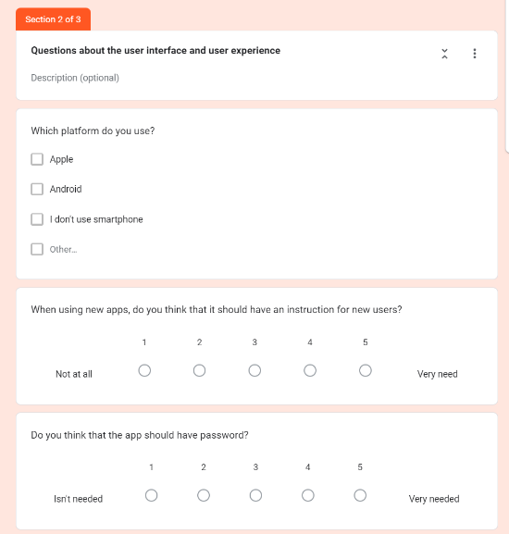

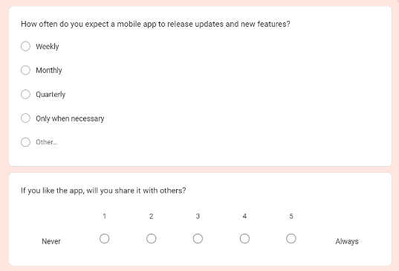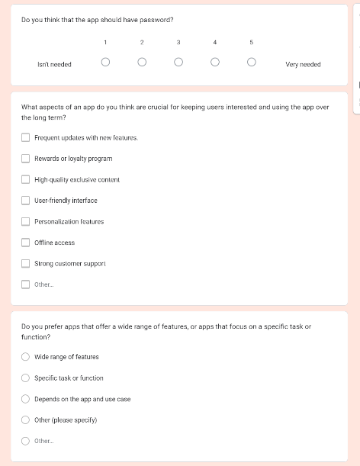

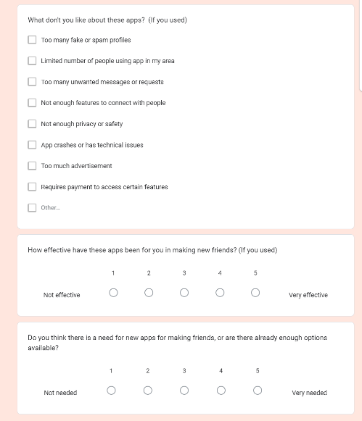

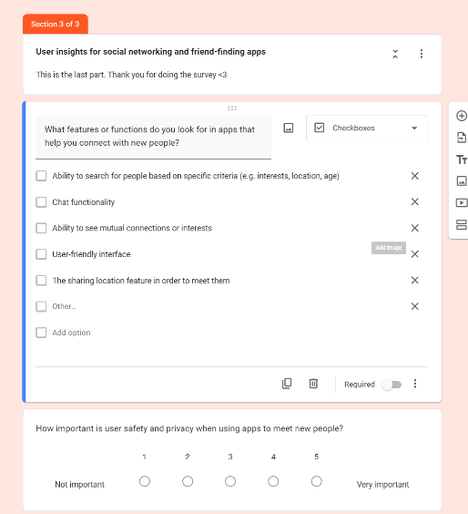

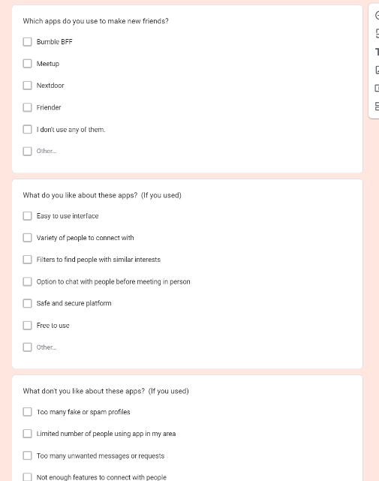

### **A screenshot of a graph Description automatically generated with low confidence9.4.2 Survey answers**

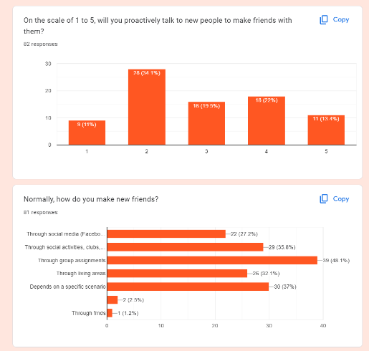

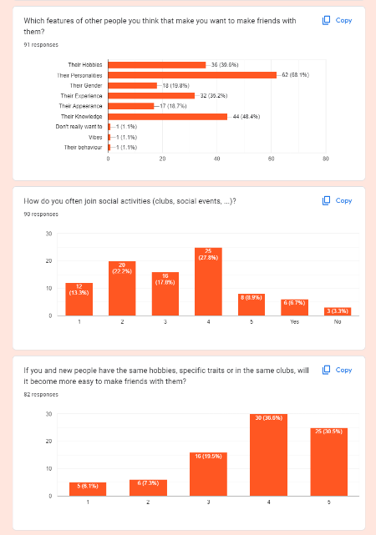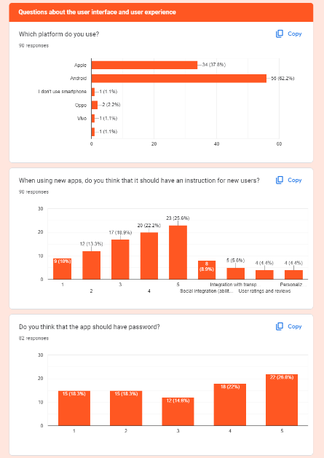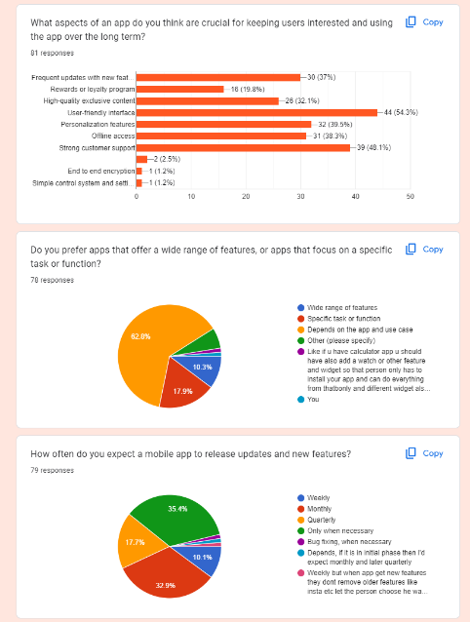

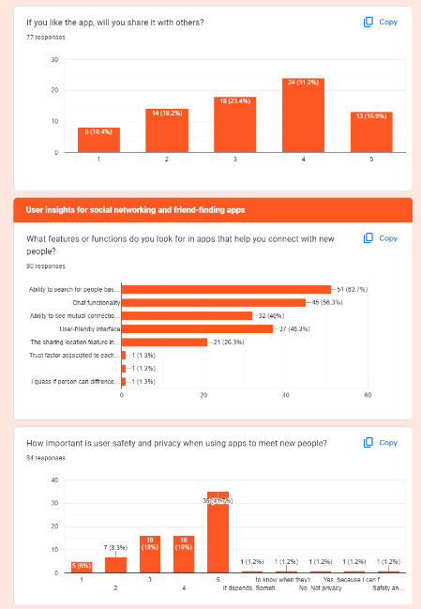

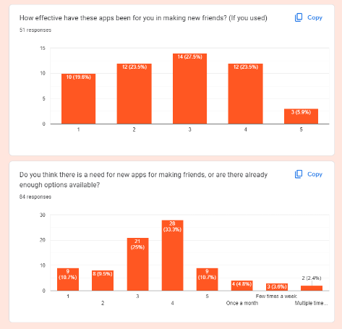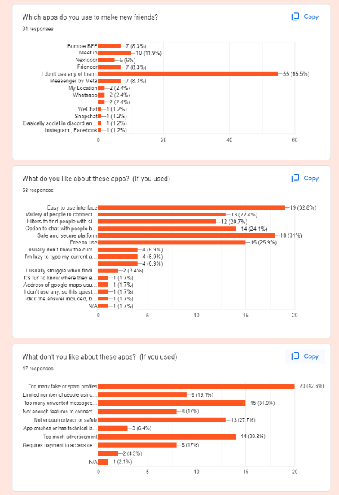

**9.5 Benchmark test description**